Well Log's Compressibility Prediction Using Drilling Cores by Artificial Neural Network

Jafar VALI ¹, Farnusch HAJI ZADEH ^{2*},
1: J.Vali@urmia.ac.ir Department of Mining Engineering, Urmia University, 11th km of Sero-Urmia Blvd., 5756151818, Urmia, Iran,
2*: (corresponding author: Farnusch.Hajizade@gmail.com; F.Hajizadeh@urmia.ac.ir) Department of Mining Engineering, Urmia University, 11th km of Sero-Urmia Blvd., 5756151818, Urmia, Iran

Abstract
Pore volume compressibility of (PVC) is one of the important parameters in the reservoir, but not much research performed on new methods of prediction in carbonate rocks. Using artificial neural network algorithms, the compressibility data in the well axis in Sarvak Formation has been investigated. Determination of pore volume compressibility (PVC) with artificial neural network algorithms has been investigated using petrophysical data of drilling cores. Extension of PVC data along the well axis is possible through artificial neural network algorithms and petrophysical logs, similar to drilling core data.
Some attributes were used to investigate the artificial neural network algorithms on well logs and seismic data in the well axis. Optimum correlation coefficient and target error characteristics and production in each well have been done. The correlation coefficient between the predicted compressibility and drilling core data shows 78%. The high correlation coefficient indicates the high accuracy of the model and the optimal choice of artificial neural network algorithms. Comparing the compressibility obtained from petrophysical data and seismic attributes in the well axis shows the high accuracy of both methods.
Keywords: Wells Logs, Drilling Cores, Sarvak Formation, Pore Volume Compressibility, Artificial Neural Network

Introduction

Reservoir compressibility, which provides the energy required for oil production, is of great importance in reservoir engineering studies and is still under investigation by many researchers. (Chin et al., 2002; Haynes et al., 2008; Moosavi et al., 2022). The compressibility of reservoir rocks has been reported as one of the important factors in subsidence caused by fluid extraction from the reservoir. (Daïm et al., 2002; Ferronato et al.; 2005, Xu et al., 2006) In terms of structural and textural complexities of carbonate rocks, compressibility is not only a function of rock porosity, but also depends on various other petrophysical parameters. Empirical relationships versus porosity are used due to insufficient data (Gilberto Silva et al., 2015). Using density logs, neutron porosity, acoustic impedance and also seismic characteristics as input data of neural network algorithms, the compressibility of the well axis predicted.

Geological Description of the Sarvak Formation.
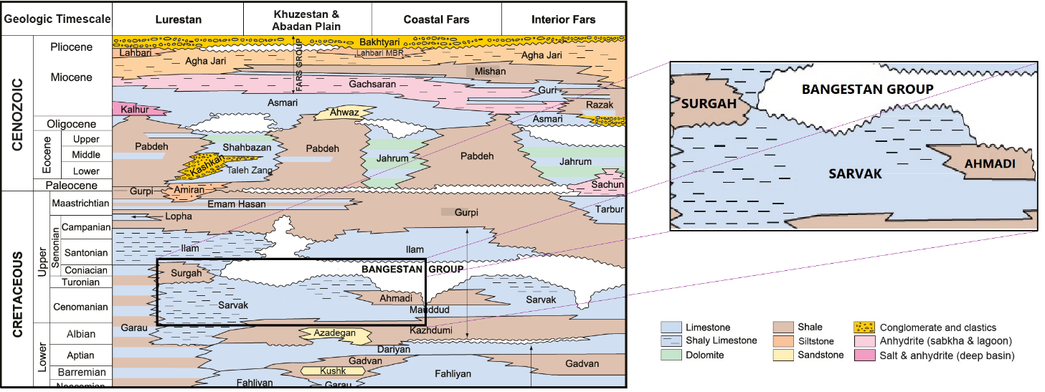
Middle Cretaceous (Cenomanian) Sarvak Formation is one of the stratigraphic units of Bangistan Group in southern Iran (Figure 1). Dissolution and neomorphic due to diagenesis increase the quality of the reservoir. Cementation, compaction and microtization have an adverse effect on the reservoir properties. [Sabuhi et al. 2022] This formation has different diagenetic changes, including dissolution and dolomitization, which affects the porosity and permeability of the reservoir and thus the production rate. [Masoudi et al. 2012].
Figure 1 Geological background of the selected lithology investigated in this study. Lithostratigraphic column of SW Iran, illustrating stratigraphic units of the Cenozoic and Cretaceous. [Esrafili Dizaji and Rahimpour 2019]

Theoretical background
Many researchers have studied the experimental relationships of compressibility, mainly against porosity. Horn (1995) predicted some correlations for calculating PVC versus primary porosity for limestone.
(Equation 1) | $$C_{p}=\exp{(}4.026-23.07ϕ+44.28ϕ^{2})×10^{-6} psi-1$$
Jalalh (2006b) shows that PVC increases as porosity decreases, and repeating the compressibility test results in more compressibility due to the rearrangement of the rock matrix.
(Equation 2) | $C_{p}=\left(\frac{1}{1.022^{-2}+1.681^{-2}(ϕ)^{1.05}}\right)×10^{-6}{psi}^{-1}$
Akhoundzadeh et al., (2011) developed a robust correlation with porosity, which shows by the following experimental relation.
(Equation 3) | $C_{p}=\left(\frac{1}{0.367+0.099Ln\left(ϕ\right)}\right)×10^{-6}{psi}^{-1}$

In the above equations; C_{p} is pore volume compressibility in (10⁻⁶ psi⁻¹) and φ shows as a fraction.
Petrophysical well logs can be a valuable tools for determining petrophysical parameters along the well axis due to their continuity, availability, and low cost. (William More et al., 2011).
Artificial neural network is used in many aspects of the oil and gas industry (Tanko and Bello, 2020). The simplest and most efficient type of neural network is the multilayer perceptron model, which consists of an input layer, one or more hidden layers, and an output layer (Kasabov, 1996). Bayesian Regularization Artificial Neural Networks (BRANN) algorithm is a mathematical process that transforms a non-linear regression into a linear regression (F. Burden, 2008). Scaled conjugate gradient SCG is based on a class of optimization techniques known in numerical analysis as conjugate gradient methods. (Møller, 1990). LMA (Levenberg K., 1944 and Marquardt DW., 1963) is a nonlinear least squares method that belongs to the field of continuous optimization. It minimizes the multivariate function, which is expressed as the sum of squared errors (Ramadsan et al., 2017). Considering the speed of convergence of Levenberg-Marquardt, Bayesian Regularization and scaled conjugate gradient in forward networks, these algorithms have been used to train the target network and parameter errors have been used to evaluate the model's performance (vali, Hajizadeh, 2023). Probability Neural Networks (PNN) uses a class of probability density function estimators that asymptotically approximate the underlying parent density, provided it is smooth and continuous. (Parzen, 1962).

Materials and methods
To measure the compressibility, were prepared 280 carbonate samples from Sarvak Formation of four wells in SW of Iran. The petrophysical properties of the cores, including porosity, grain density, and air permeability of the samples, are measured at ambient conditions. Laboratory measurement of rock-compressibility are measured. Density, neutron porosity, and acoustic impedance logs in wells used to predict compressibility using artificial neural network algorithms along the axis of the well. Figure 2 shows the workflow of the present research.
Compressibility prediction in well axis
An overview of the subject’s background and library studies
Laboratory measurement of petrophysical analysis
Laboratory Measurement of rock-compressibility
Well Log data gathering

Predicted Cp from K & Φ by ANN algorithms
Predicted Cp from well log data (Density, neutron porosity and acoustic impedance by ANN algorithms
Comparison Cp Lab & Cp predicted from well log data
Comparison compressibility of lab data and researcher's experimental relations
Yes
No
Good Results?
(Optimal correlation and errors)

Figure 2 Workflow used for this study

Result and Discussion
The comparison of the compressibility of the pore volume of laboratory data and the experimental relationship of some researchers is shown in Figure 3. The experimental relationships of researchers cannot meet the expectations of correct prediction. Although the laboratory compressibility data in terms of porosity has been shown to have a good correlation, but it does not agree with the researchers' experimental data.
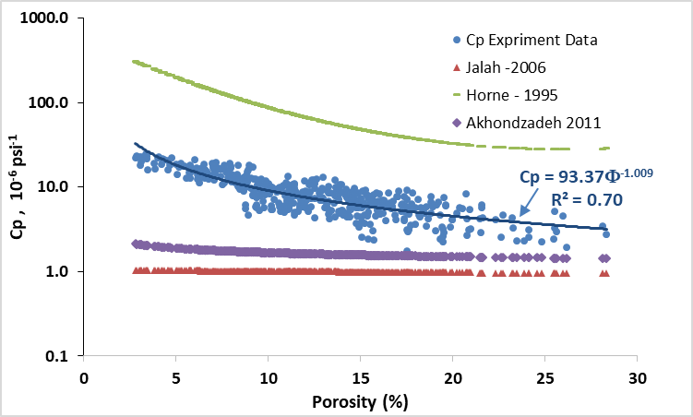
Figure 3 Pore volume compressibility of laboratory measurement data and experimental relationships such as, Horne (1995), Jalalh (2006), and Akhoundzadeh et al. (2011)

To predict and estimate the target in each well, the best data must be selected. Density logs, neutron porosity and acoustic impedance can be correlated with compressibility. Figure 4 shows the extraction of selected characteristics in each well. Predicted of compressibility by selected well attributes (Density, neutron porosity, and acoustic impedance logs) at well location. It can be used to determine the various attributes of seismic data to find the optimal correlation, and error along the well axis between the generated characteristics and the target.
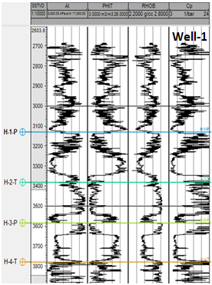 | 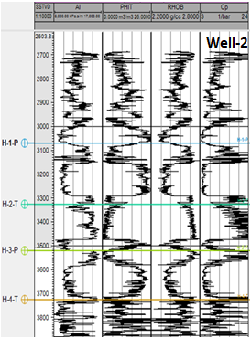 | 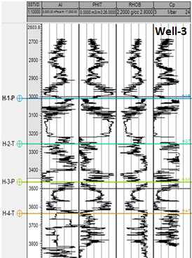 | 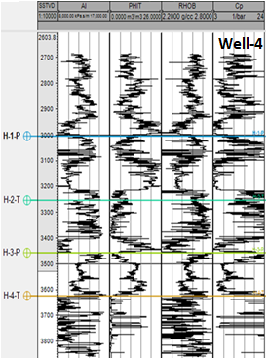
(a) | (b) | (c) | (d)
Figure 4: Predicted of compressibility by selected well attributes (Density, neutron porosity, and acoustic impedance logs at well location. (a): well no. 1, (b): well no. 2, (c): well no. 3, and (d): well no. 4.

On the other hand, in addition to the logs in the well, seismic characteristics along the axis of the well can be used to predict compressibility. Figure 5 shows optimal number of attributes used to estimate compressibility with minimum error. Analysis of multiple seismic attributes was performed to select the best set. The best fit of the seismic attributes used to estimate compressibility with minimum error is the most consistent with 11 attributes. This Figure shows created characteristics of the seismic data to find the optimal correlation and error between the generated characteristics and the target report
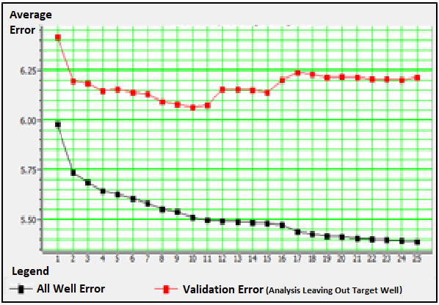
Figure 5: The optimal number of attributes used to estimate compressibility with minimum error.

Figure 6 shows compressibility of wells by density, neutron porosity, and acoustic impedance logs versus compressibility predicted by seismic attributes in the artificial neural network.
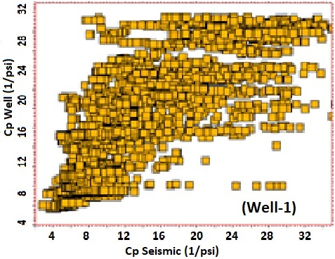 | 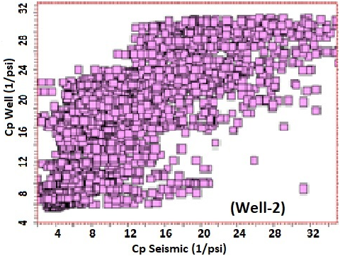
Correlation Coefficient = 0.70 | Correlation Coefficient = 0.78
(a) | (b)
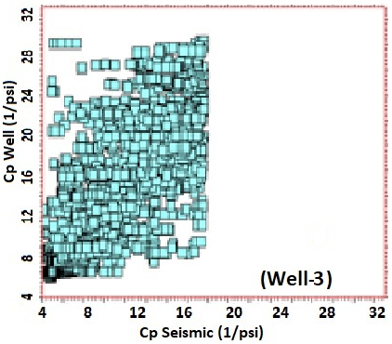 | 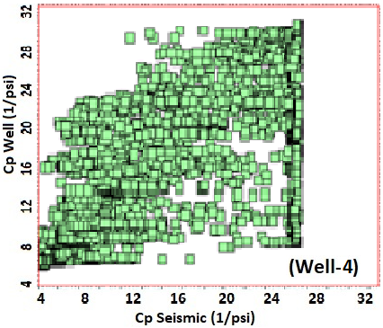
Correlation Coefficient = 0.81 | Correlation Coefficient = 0.80
(c) | (d)
Figure 6 : The ratio of the well's compressibility versus seismic attributes' compressibility, with correlation coefficient at each well data, (a): well no. 1, (b): well no. 2, (c): well no. 4, and (d): well no. 5.
Using probabilistic neural networks (PNN) and determining the suitable parameters for this method obtained eleven attributes as in the previous method. In Figure 7 using PNN and determining the best parameters, compared by well data compressibility.
The high correlation coefficient showed the high accuracy of the model and the optimal choice of algorithms (Figure 8). Using artificial neural network algorithms along the axis of the well, the correlation between predicted compressibility and the actual compressibility of wells was obtained 78% (Figure 9).
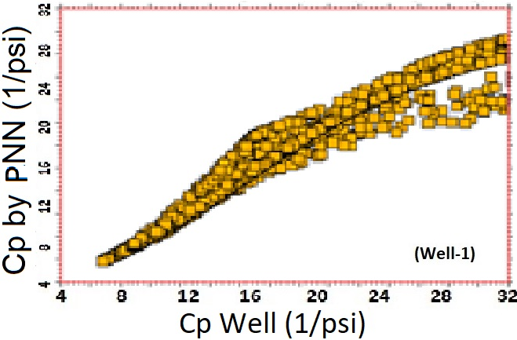 | 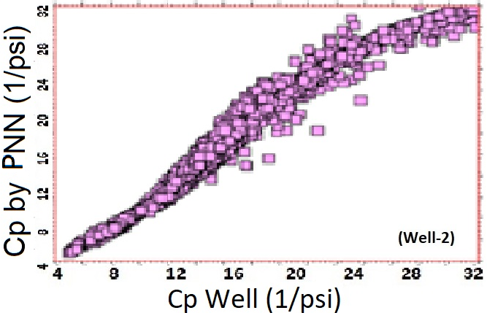
C_{P-ANN}= 1.08 * C_{p-Log} – 0.07  Correlation Coefficient = 0.98 | C_{P-ANN}= 0.85 * C_{p-Log} + 0.74  Correlation Coefficient = 0.96
(a) | (b)
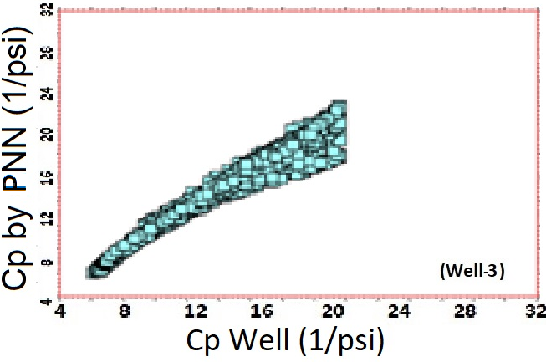 | 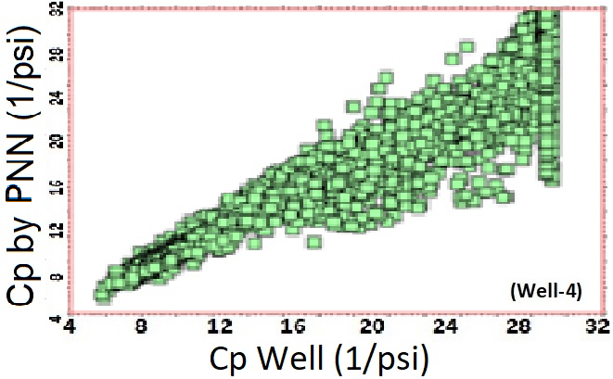
C_{P-ANN}= 0.92 * C_{p-Log} + 0.45  Correlation Coefficient = 0.96 | C_{P-ANN}= 0.97 * C_{p-Log} + 1.17  Correlation Coefficient = o.99
(c) | (d)
Figure 7: The compressibility at each well versus the ANN, along with the correlation coefficient and the relation equation of them, (a): well no. 1, (b): well no. 2, (c): well no. 3, and (d): well no. 4.

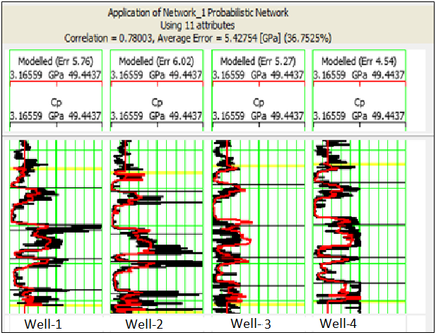 | 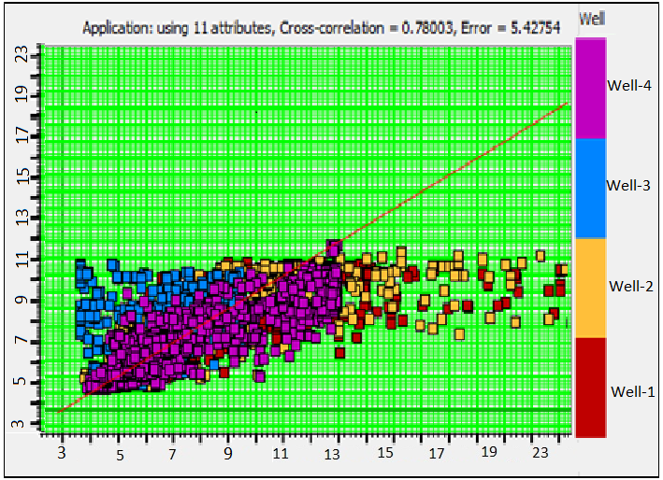
Figure 8: Application of PNN method in predicting the compressibility parameter in all selected wells. | Figure 9: Using the PNN method, the correlation between the predicted and the real compressibility of wells shows 78%.

Conclusion

In this study, Compressibility prediction has been investigated using an artificial neural network method. The following conclusions have been obtained:
- Although the laboratory compressibility data versus porosity shows to have a good correlation, but the experimental relationships of researchers cannot meet the expectations of correct prediction.
- Input attributes of artificial neural network directly related to compressibility, such as density, neutron porosity, and acoustic impedance, was used.
- The extraction of the seismic attributes was done to find the correlation and optimal error between the generated attributes and the target at each well.
- Using a probabilistic neural network algorithm, the correlation between the predicted compressibility and the compressibility of the well-axis is about 78%.

Acknowledgment
The authors express their sincere thanks to the Research Institute of Petroleum Industry (RIPI) for providing facilities and data.

Nomenclature
Parameters
AI: Acoustic Impedance.
ANN: Artificial Neural Network.
BRANN: Bayesian Regularization Artificial Neural Network.
CMS-300: Core Measurement System Apparatus.
Cp: Pore Volume Compressibility, Variation in Pore Volume (Vp) with Change in Confining Stress at Constant Pore Pressure.
LMA: Levenberg and Marquardt Artificial.
LM: Levenberg–Marquardt.
PNN: Probabilistic Neural Networks.
PVC: Pore Volume Compressibility.
SCG: Scaled Conjugate Gradient.
V_{p}: Pore Volume.

Greek letters
Φ: Porosity, fraction, or percentage.

Reference
- Burden F, Winkler D., 2008 "Bayesian regularization of neural networks" Methods Mol Biol.; 458: 25-44٫ Doi: 10٫1007/978-1-60327-101-1_3٫ PMID: 19065804. Chapter published 2008 in Methods in Molecular Biology™ on page s23 to 42, DOI: 10.1007/978-1-60327-101-1_3.
- Datta Ramadasan, Marc Chevaldonné and Thierry Chateau, 2017 " LMA: A generic and efficient implementation of the Levenberg–Marquardt Algorithm", SOFTWARE: PRACTICE AND EXPERIENCE, Softw. Pract. Exper. Published online in Wiley Online Library (wileyonlinelibrary.com). DOI: 10.1002/spe.2497.
- Esrafili-Dizaji and H. Rahimpour-Bonab, 2019, " Carbonate Reservoir Rocks at Giant Oil and Gas Fields in SW IRAN and the Adjacent Offshore: A Review of Stratigraphic Occurrence and Poro-Perm Characteristic", Journal of Petroleum Geology, Vol. 42(4), October 2019, pp 343-370,
- F. Daïm, R. Eymard, D. Hilhorst, M. Mainguy, and R. Masso, 2002"A preconditioned conjugate gradient based algorithm for coupling geomechanical-reservoir simulations" Oil & Gas Science and Technology – Rev. IFP, Vol. 57, No. 5, pp. 515-523, DOI: 10.2516/ogst:2002034.
- Gilberto Peixoto da Silva Jr, Daniel R. Franco, Giovanni C. Stael, Maira da Costa de Oliveira Lima, Ricardo Sant'Anna Martins, Olívia de Moraes França, Rodrigo B.V. Azeredo, 2015, "Petrophysical studies of north American carbonate rock samples and evaluation of pore-volume compressibility models", Journal of Applied Geophysics 123 256–266, DOI: 10.1016/j.jappgeo.2015.10.018
- H. Akhoundzadeh, J. Moghadasi, and B. Habibnia, 2011 "Correlation of Pore Volume Compressibility with Porosity in One of the Iranian Southern Carbonate Reservoirs," presented at the Third National Conference of Petroleum Engineering.
- H. Xu, 2006 "Production induced reservoir compaction and surface subsidence, with applications to 4D seismic," Ph.D. Dissertation Submitted, Department of Geophysics, Stanford University.
- Haynes, A. Abdelmawla, and S. Stromberg, 2008 "Impact of Pore Volume Compressibility on Recovery from Depletion Drive &amp; Miscible Gas Injection in South Oman," SPE 115274, presented at at the 2008 SPE Annual Technical Conference and Exhibition, Denver, Colorado, USA, 21–24.
- Jalalh, 2006 "Compressibility of porous rocks: Part II. New relationships," Acta Geophysica, V. 54, I. 3, pp. 399-412, DOI 10.2478/s11600-006-0029-4
- Kasabov, N.K., 1996 "Foundations of Neural Networks, Fuzzy Systems, and Knowledge Engineering", in The MIT Press, ISBN: 9780262112123.
- L.Y. Chin, L.K. Thomas, J.E. Sylte, and R.G. Pierson, 2002 "Iterative coupled analysis of geomechanics and fluid flow for rock compaction in reservoir simulation" Oil & Gas Science and Technology – Rev. IFP, Vol. 57, No. 5, pp. 485-497.
- Levenberg K., 1944 "A method for the solution of certain problems in least squares", Quarterly of AppliedMathematics, 2:164–168, DOI: 10.1090/qam/10666.
- M. Ferronato, G. Gambolati, P. Teatini, and D. Bau, 2005 "Stochastic poromechanical modeling of anthropogenic land subsidence" International Journal of Solids and Structures, Vol. 43, 3324–3336, DOI: 10.1016/j.ijsolstr.2005.06.090.
- M. Sabouhi, R. Moussavi-Harami, A. Kadkhodaie, P. Rezaee, M. Jalali, 2022, " A qualitative-quantitative approach for studying the impact of facies and diagenesis control on the rudist biostrome of the Sarvak Formation, Abadan plain, SW Iran" Journal of Petroleum Science and Engineering 212 110245
- Marquardt DW. 1963 "An algorithm for least-squares estimation of nonlinear parameters", Journal of the Society for Industrial and Applied Mathematics, 1963, Vol.11 (2), p.431-441, DOI: 10.1137/0111030.
- Martin F. Møller, 1990 " A Scaled Conjugate Gradient Algorithm for Fast Supervised Learning", 19 (339). https://doi.org/10.7146/dpb.v19i339.6570.
- Parzen, E., 1962 "On estimation of a probability density function and mode," The Annals of Mathematical Statistics, volume 33 issue 3 on page s1065 to 1076, DOI: 10.1214/aoms/1177704472.
- P. Masoudi, B. Tokhmechi, A. Bashari, and M. A. Jafari, 2012, "Identifying productive zones of the Sarvak formation by integrating outputs of different classification methods," Journal of Geophysics and Engineering, vol. 9, pp. 282-290,
- Roland N. Horne. 1995 "Modern well test analysis, A computer-aided approach" Petro Way, 2nd Ed.
- S. A. Moosavi, H. A. Bakhtiari, and J. Honarmand, 2022"Estimation of Pore Volume Compressibility in Carbonate Reservoir Rocks Based on a Classification," Geotechnical and Geological Engineering, vol. 40, pp. 3225-3244.
- Tanko A. and Bello A., 2020 " Modeling of Pore Pressure using Artificial Neural Networks" Oil & Gas Research, Vol 6(1), DOI: 10.4172/2472-0518.1000168, ISSN 2472-0518.
- Vali J., Hajizadeh F., 2023 " Comparison of Cementation Factor Determination by Artificial Neural Network
- Method and Optimized Experimental Relations in Carbonate Rocks", Journal of Petroleum Science and Technology 11(1): 29, Pages 17-28, DOI: 10.22078/JPST.2023.4840.1808
- William R. Moore, Y. Zee Ma, Jim Urdea, and Tom Bratton, 2011 " Uncertainty Analysis in Well-Log and Petrophysical Interpretations" American Association of Petroleum Geologists. DOI:10.1306/13301405M963478

