Pt-Impregnated ZnO/HZSM-5 Catalyst for Aromatics Synthesis from CO₂ Hydrogenation
Nakisa Yaghobi, *, Milad Rasouli

Department of Petrochemical, Iran Polymer and Petrochemical Institute, Tehran, Iran
n.yaghobi@ippi.ac.ir

A highly efficient bifunctional catalysts containing platinum-impregnated ZnO-loaded HZSM5 and its performance on direct hydrogenation of CO₂ to aromatics was investigated. Methanol-mediated pathway was applied for hydrogenation reactions. ZnO was introduced to the zeolite structure through hydrothermal synthesis and illustrated gradual enhancement in surface area and pore volume of the zeolite. Pt was added to the zeolite by post treatment partial vacuum impregnation technique. The amount of zeolite acidity indicated a key role in CO₂ conversion and aromatics selectivity. NH₃-TPD analysis suggested that introduction of both ZnO and Pt increased the strong acid sites and conversly decreased the weak acid sites. Furthermore, some new acidic sites were appeared in zeolite structure after ZnO loading. Furthermore, XPS results proposed that most of the zinc species located on the surface of the zeolite as oxide form, whereas, the platinum is located in the catalysts in both metallic and oxide form. Increasing the amount of zinc load to 10 wt%, led to creation of some ZnO clusters that decreased the catalyst stability. However, 0.1 wt% Pt-8 wt% Zn/HZSM5 catalyst denoted as (P(8)Z/HZ5) showed the best results for CO₂ conversion (88.3%) and aromatics selectivity (69.2%) with low CO selectivity (9.8%) compared to other zeolites.

Keywords: ZnO/HZSM5 catalysts, Pt impregnation, CO₂ Hydrogenation, Aromatics

* Corresponding author. Tel: +98 (21)44580000, E-mail address: n.yaghobi@ippi.ac.ir

Introduction
The increasing trend of greenhouse gas (CO₂) emissions, which occurred as a result of the consumption of fossil fuels in recent decades, has led to the creation of environmental hazards such as global warming and acidification of water resources. On the other hand, low-efficiency energy of clean energy sources restricts their usage. Therefore, converting CO₂ into valuable fuels (e.g., gasoline) and chemicals (e.g., methanol, olefins and aromatics) through hydrogenation reaction can cause the production of chemicals with high added value despite reducing the emission of this greenhouse gas [1-5]. Hydrogenation of CO₂ is one of the complex processes, the output of which largely depends on the catalyst synthesis conditions as well as the reaction conditions. Although many advances have been made in the field of converting CO₂ into short-chain hydrocarbons, the direct conversion of this gas into long-chain hydrocarbons such as aromatics still faces challenges because of high barrier of carbon-carbon coupling [6, 7]. The methanol-mediated pathway is recognized as a main route for hydrogenation of CO₂ to aromatics. In this way, a combination of metal oxide and acidic zeolite is applied to convert CO₂ to methanol and mediated-methanol to hydrocarbon compounds, respectively [8].
Among the different types of solid acids, ZSM-5 zeolite with MFI topology obtained to be the efficient catalyst for selective synthesis of aromatics, owing to its physicochemical properties such as well-defined 3-dimensional structure, acidity and hydrothermal and chemical stability [9]. The selectivity of zeolite catalysts largely depends on density and the nature (Bronsted or Lewis type) of its acid sites. The introduction of transition metals to zeolites structure greatly affects the acidity of the catalyst. Metal promoters can be incorporated into ZSM-5 zeolites through different methods such as wet impregnation (WI), hydrothermal synthesis (HS), ion exchange (IE), chemical vapor deposition (CVD) and solid-state ion exchange (SS) [10]. In our previous work [11], we investigated the influence of preparation methods in direct hydrogenation of CO₂ to aromatics. It was observed that introducing zinc oxide through WI, IE, SS, and CVD methods decreased the surface area and micropore volume to different extents, while addition of ZnO by Hydrothermal Synthesis slightly increased the both parameters. ZnO/HZSM-5-HS prepared through hydrothermal synthesis showed the aromatics selectivity of 57.5% as well as CO₂ conversion of approximately 85%. Zhang et al. [12] studied the conversion of methanol to aromatics through surface modification of Zn/P/HZSM-5 and found that increase in total acidity of catalyst promotes the methanol conversion and aromatic yields (>60%). Furthermore, the small amount of weak external acid sites directs the reaction towards higher selectivity of PX from the usual 23-24% to 89.6%. Wang et al. investigated the influence of ZnO/HZSM-5 catalysts in methanol to aromatics (MTA) reactions synthesized through atomic layer deposition (ALD). They revealed that ZnO/HZSM-5 catalyst (treated with 40 ALD cycle) illustrated twofold increase in aromatics yield (60.3%) toward HZSM-5 zeolite (28.3%). In addition, it was observed that the catalyst prepared through ALD method showed more stability in MTA process in comparison with WI and IE methods [13]. Cui et al. [14] reported that combination of Na-modified ZnFeO_{x} and HZSM-5 zeolite indicated high performance for direct synthesis of aromatics from CO₂ and H₂ with 41.2% CO₂ conversion and the maximum selectivity of 75.6 % for all hydrocarbons. Also the selectivity of CO and CH₄ was found to be less than 20% over the prepared catalyst. Xu and coworkers [15] applied Na/Fe containing HZSM-5 catalyst for direct conversion of CO₂ to aromatics. They revealed that over composite catalyst, the selectivity of catalyst to aromatics obtained to be over 94% and the addition of SiO₂ to the catalyst structure considerably increased the PX selectivity from 24–26% to 70%. Dai and coworkers [16] studied the CO₂ hydrogenation over Fe-K/alkaline Al₂O₃ and P/ZSM-5 tandem catalysts. Introduction of phosphorus has changed the acidity of zeolite and increased the amount of medium acidic sites. Also, the addition of phosphorus has led to an increase in the production of aromatics, and the optimal amount of 0.8% phosphorus has resulted in a conversion of 36.4% for carbon dioxide and a selectivity of 35.5% for aromatics. Wang and coworkers [17] investigated aromatics synthesis from CO₂ hydrogenation over ZnZrOx catalyst integrated with chain-like HZSM-5 nanozeolite. The CO₂ conversion was obtained to be 17.5 % with CO selectivity of 23.8 %. Also the maximum selectivities of para-xylene (PX) and tetramethylbenzene (TeMB) in aromatics was found to be 28.9 % and 74.1 %, respectively. Wei and coworkers [18] synthesized Fe-based HZSM-5 catalysts and investigated the role of Bronsted acid sites on the light aromatic synthesis and coke formation in CO₂ hydrogenation. They observed that the Bronsted acid sites are the main active sites in catalyst for aromatization reactions and enhancing Bronsted acidity remarkably lead to higher production of light aromatics. Moreover, many other studied have been accomplished for direct synthesis of aromatics from CO₂ through modified catalysts such as In₂O₃/HZSM-5 [19], NiO/ZnO/HZSM-5 [20], CuZnO/ZSM-5 [21], ZnZrO/HZSM-5 [22-24], ZnAlOx/HZSM-5 [25] and ZnCrO/HZSM-5 [26].
In this work, ZnO/HZSM-5 catalysts with different amount of zinc were prepared through hydrothermal synthesis and the influence of platinum impregnation over ZnO-containing zeolite was studied in direct hydrogenation of CO₂ to aromatics. The physic-chemical properties of synthesized catalysts were determined by different techniques such as; nitrogen adsorption, elemental analysis (ICP), scanning electron microscope (SEM), X-Ray diffraction (XRD), Fourier transform infrared (FT-IR), temperature programmed desorption of NH₃ (NH₃-TPD), X-ray photoelectron spectroscopy (XPS) and Thermogravimetric analysis (TGA). The main focus of this research is on adjusting the acidity of the synthesized catalysts applying various amount of zinc and the effect of platinum species on developing the facile and highly effective Pt-ZnO/HZSM-5 hydrogenation catalyst with high CO₂ conversion and aromatic yield.

Experimental
Catalyst Preparation
The parent HZSM-5 zeolite was synthesized through hydrothermal synthesis according to the procedure explained in our previous research [11]. For this reason, a mixture of 2.9 g of sodium hydroxide and 25 mL distilled water was stirred for 2 h until being dissolved. 24 mL tetraethyl orthosilicate (TEOS) was slowly added to the solution for 2h and stirred (120 rpm) for 12 h at 25 °C (solution A). Mixture B was prepared by adding 0.5 g Al₂(SO₄)₃ to the aqueous solution of 4.0 g tetrapropylammonium bromide (TPABr) and 1.7 mL H₂SO₄ (96%). After stirring at 25°C for 2 h, mixture B was added dropwise into mixture A. The mixture was transferred into an autoclave to crystallize at 180°C for 120 h. The resultant mixture were filtered under vacuum, washed with hot distilled water, dried at 80 °C for 12 h and eventually calcined in air at 550 °C for 3 h [27]. For hydrothermal synthesis of ZnO/HZSM-5, desirable amount of Zn(CH₃CO₂)₂.2H₂O as a sources on zinc was added to the synthesis gel during synthesis of HZSM5. The final ZnO content in the prepared catalysts was obtained to be 5, 8 and 10 wt%.
Pt was impregnated to the ZnO/HZSM5 catalysts through partial vacuum impregnation which described in our previous work [28] using H₂(PtCl₆).6H₂O salt. The ultimate catalysts included 0.1 wt% Pt promoter.

Catalyst Characterization
ICP-AES elemental analysis was applied to measure the content of metals loading in the catalysts structure using Perkin Elmer Optima 200DV. For the ICP measurements 20 mg of zeolite powder dissolved in a 1.5 mL solution of HF/HNO₃/H₂O (1:1:1) acid mixture. The crystallinity of the prepared catalysts were calculated by X-ray diffraction (XRD) using D8 Advanced Bruker AXS X-ray diffractometer with Cu Kα radiation at 40 kV and 40 mA in the range of 2θ = 5° - 50° with a scale of 0.08° step per 1 s. N₂ adsorption-desorption isotherms were recorded to calculate the surface area and pore volume of the catalysts. The experiments were conducted at P/P0=0.99 and 77 K on a Micrometrics ASAP 2020. All the measurements were performed after degassing the samples at 150°C for 20 h. Brunauer-Emmett-Teller (BET) analysis conducted over sorption analyzer (ASAP 2010, Micrometrics Co.) to measure the total surface area (S_{BET}) and total volume (V_{total}) of the prepared catalysts. The crystal morphology of synthesized zeolites were recorded by Field-emission Scanning electron microscopy (FE-SEM) on a ZEISS SIGMA VP-500 electron microscope operated at 20 kV. Temperature programmed desorption of NH₃ (TPD-NH₃) was carried out on Micrometrics Auto Chem 2920 device to determine the density and strength of the catalysts acid sites. 100 mg of each sample was treated in He (25 ml/min) at 550°C for 2 h, cooled to the 100°C and then exposed to the ammonia for 1 h to sweep away physically-absorbed NH₃. Finally, the amount of desorbed ammonia was recorded using mass spectrometry (MS) in the temperature range of 150-700°C with the rate of 10°C min⁻¹. The nature and strength of the surface acid sites in the prepared catalysts were measured through FT-IR spectra of adsorbed pyridine (Py-IR) using Perkin Elmer system 2000 spectrometer. Before the test, 20 mg of the zeolite powder pressed into a self-supporting wafers, pretreated at 450°C (heating ramp of 2°C/min) under helium atmosphere. After that slightly cooled to the room temperature, exposed to the pyridine for 30 min and then the spectrum was recorded. X-ray photoelectron spectroscopy (XPS) experiments were recorded at room temperature employing Al Kα radiation by using an ESCA spectrometer (E.S.C.A spectrometer from V.G. SCIENTIFIC LTD). The amount of carbon deposition content of used catalysts measured through Thermogravimetric analysis (TGA) on a Perkin-Elmer Diamond TGS-2. The temperature increased from the ambient to 800 °C with a heating rate of 10 °C min⁻¹ under air flow (50 mL min⁻¹).

Catalyst test
Gas phase CO₂ hydrogenation reactions were carried out in a tubular fixed-bed, continuous-flow reactor (inner diameter = 10 mm). 2 g of catalyst (mesh 20-30) diluted with equal volume of quartz (mesh 20-30 with purity > 99.99%) was packed in the middle of stainless steel vertical reactor, supported with quartz wool. Prior the reaction, the catalysts were in situ reduced at atmospheric pressure and 400 °C for 8 h under H₂ then cooled to the reaction temperature. The reactant gas (23% CO₂, 74% H₂, and 3% N₂) was delivered into the reactor by calibrated mass flow meter (BROOKS-SLA5800). The reaction was performed at temperature of 350 °C and the pressure of 3 MPa. The liquid hydrocarbons were analyzed online using Gas Chromatograph (GC) (with flame ionization detector) fitted with capillary columns CP-Silpona CB under steady-state conditions. CO₂ conversion was calculated from the following formulas:
$${CO}_{2} Conversion=\frac{{CO}_{2} in-{CO}_{2} out}{{CO}_{2} in} ×100$$
$${CO}_{2} in=mols of {CO}_{2} at the inlet ; {CO}_{2} out=mols of {CO}_{2} at the outlet$$

Selectivity of i product (S_{i}):
$$S_{i}=\frac{F_{i} }{\sum{F_{i}}}×100\%$$

Where F_{i} is the molar flow rate of i product in the reactor outlet stream, expressed in C equivalent units.

Results and discussion
Catalyst structure, morphology and textural properties
The chemical composition of the parent and modified HZSM-5 zeolites are given in Table 1. The amount of bulk ZnO and surface ZnO is determined by ICP and XPS analysis, respectively. The higher surface value in Zn-containing catalysts proposed that the ZnO species is more located on the surface of the zeolites (Table1).
The N₂ adsorption/desorption isotherms of the parent and modified HZSM-5 catalysts are indicated in Fig. 1. Furthermore, the textural properties are presented in Table 1. Comparing to the parent HZSM-5 zeolite, ZnO-containing zeolites illustrated slight increase in surface area and pore volume. Higher amount of surface area in Zn-loaded zeolites can be justified by the fact that introducing ZnO through synthesis increase the nucleation rete in zeolite synthesis which conforms to the XRD results [29, 30]. Yang et al. [31] reported that enhance in crystallinity of zeolite by introducing Zn species could be due to the synergistic effect of zinc with zeolites aluminosilicate framework. Moreover, the mesoporous volume of modified HZSM-5 zeolites indicated to be more than the parent zeolite which can be a reason for higher stability and longer life time. Ni et al. [32] proposed that intra-crystalline mesopores could providing more spaces for coke storage.
XRD spectra of parent and modified HZSM-5 catalysts are indicated in Fig. 1, which confirms that all prepared zeolites conforms well to the MFI structure (JCPDS, 37-0359 [33]). It was illustrated that parent HZSM-5 zeolite retained its crystallinity during incorporation of metals (Table 1). The intensity of Z/HZ5 catalysts found to be 100% which can be justified by the fact that incorporation of zinc species to the synthesis gel acted as nuclei and led to crystallization promotion. Besides, the diffraction peak became visible in Z/HZ5 samples at 36.2° reveals the presence of crystalline ZnO (JCPDS, 36-1451 [34]) located on the surface of zeolites, whereas, no new phase appeared on the XRD profile of Pt-impregnated zeolites. Based on the results presented by Abdelsayed et al. [35], zinc species can be located inside the zeolite in two ways; Zn(OH) which is tightly bounded to the Bronsted acid sites and ZnO which can be placed at the surface of the zeolite.
FE-SEM micrographs of the parent and modified HZSM-5 catalysts are given in Fig. 3. According to the results, it can be observed that introducing ZnO through synthesis gel and Pt species by wet impregnation method does not significantly affect the zeolites morphology and crystal size. Results displayed that there is no ZnO agglomeration in Z/HZ5 catalysts and the average size of the crystals achieved to be around 300 nm. High crystallinity of Z/HZ5 zeolites is attributed to high nucleation rate and slow crystal growth [36] which conforms to the XRD results. It is noteworthy that the amorphous phase in Pt-containing zeolites is more than that in Z/HZ5 zeolites which can be ascribed to the presence of metallic platinum in zeolites structure.

Acidic properties
The strength and density of surface acid sites of the prepared zeolites are measured by NH₃-TPD which the profiles are shown in Fig. 4. Two desorption peaks at temperature of around 200 °C and 400 °C attributed NH₃ adsorbed on surface of weak and strong acid sites of catalysts, respectively [28]. The acidity density of zeolites were calculated by deconvolution and integration of NH₃-TPD profiles and summarized in Table 2. The amount of weak and strong acid sites for the parent HZSM-5 found to be 0.32 mmol NH₃g⁻¹ and 0.42 mmol NH₃g⁻¹, respectively. The addition of ZnO to the structure of HZSM-5 zeolite illustrated a significant effect on the acidity of zeolite and caused an increase in the amount of strong acid sites for all ZnO-containing zeolites. Moreover, it was observed that the concentration of weak acid site of HZSM-5 zeolites shifted to the lower temperature with the addition of ZnO species to the zeolite structure which attested that the substitution of zinc poisons the parts of weak acid sites. On the other hand, the appearance of moderate acidic sites in the structure of zeolite around 240-250 °C can be considered as the reason for the reaction of intrinsic acidic sites of HZSM-5 zeolite and zinc oxide species [37]. This finding is in agreement with the previous studies that Padro et al. [38] stated that the emergence of moderate acid sites due to the addition of ZnO particles to the zeolite can be due to the destruction of weak acid sites. Furthermore, it can be observed that impregnation of Pt on ZnO-containing HZSM-5 zeolites enhance the strong and medium acid sites, whereas, the amount of weak acid sites decreased slightly which conforms to the findings of Zhao et al. [39]. According to the results obtained in literature reports, medium and strong acid sites are known as the main active sites for dehydrogenation and cyclization of alkenes to aromatics, while, weak acid sites play an important role in the formation of coke in catalysts channels [40, 41]. P(10)Z/HZ5 catalysts presented the highest amount of strong and medium acidity with 0.652 mmol/g and 0.181 mmol/g, respectively (Table 2).
The FTIR spectra for the parent and modified HZSM-5 zeolites in the OH stretching region (3400–3800 cm⁻¹) is displayed in Fig. 5. The broad bands at 3610 cm⁻¹ and 3728 cm⁻¹ attributed to stretching of hydroxyls in Si-(OH)-Al groups [Bronsted acidity] and free internal silanol groups, respectively [42-43]. Moreover, the silanol band at 3745 cm⁻¹ can be ascribed to terminal silanol (SiOH) vibrations [42]. Diminishment in the intensity of silanol band at 3745 cm⁻¹ in all prepared zeolites can be assigned to interaction of SiOH with ZnOH⁺ cations [44]. The intensity of the broad band at 3610 cm⁻¹, attributed to Bronsted acidity, increased for all modified catalysts respect the parent HZSM-5 zeolite. Meanwhile, the Pt-containing catalysts showed more increase in the intensity of the band at 3610 cm⁻¹.
The FT-IR spectroscopy of adsorbed pyridine was applied to quantify the Bronsted and Lewis acid sites of the prepared zeolites which is depicted in Fig. 5(II). The IR band at 1450 cm⁻¹ and 1545 cm⁻¹ attributed to the pyridine adsorbed on Lewis acid sites and Bronsted acid sites, respectively [45]. The quantitative amount of Bronsted and Lewis acidity for synthesized zeolites are given in table 3. It can be observed that with increasing the ZnO content of zeolite from 5 wt% to 10 wt%, the amount of Bronsted acid sites, generally known as strong acid sites [46, 47], enhanced from 0.259 to 0.265 mmol/g, conversely, the density of Lewis acid sites showed the slight reduction. Dauda et al. [48] found that introducing 2 wt% ZnO to the HZSM-5 zeolite led to increase in the number of Bronsted acid sites and decline in the intensity of Lewis acid site. On the other hand, the addition of 0.1 wt% Pt to the ZnO-containing zeolites through wet impregnation increased the density of Bronsted acidity, while the density of Lewis acid sites indicated slight reduction. This tendency is in good agreement with the results of NH₃-TPD analysis.

XPS analysis
XPS experiment was conducted to determine the state of surface ZnO and Pt species in modified catalysts, as displayed in Fig. 6. According to the valence state of ZnO species (Zn (2p_{3/2})), two peaks were detected around 1022.1 eV and 1023.7 eV ascribed to ZnO and ZnOH⁺ species, respectively [49, 50]. The binding energy peak appearing at 1022.1 eV can be attributed to ZnO particles due to its proximity to the peak of pure ZnO (1021.8 eV) which proves the presence of ZnO species on the surface of prepared catalysts [37, 41]. Moreover, the binding energy appeared at 1023.7 eV is assigned to the ZnOH⁺ which emerged through Zn particles and acid sites [50]. The Pt 4d XPS spectrum of synthesized zeolites, regarding the ZnO content, is illustrated in Fig. 6 (II). Furthermore, the Pt 4d_{5/2} binding energy of PZ/HZ5 zeolites were distinguished at the binding energy of Pt⁰ (314.6 eV) and that of Pt²⁺O (317.3 eV) which suggests that platinum is located in the catalysts in both metallic and oxide form.
3.4. Catalytic performance of prepared catalysts in CO₂ Hydrogenation
Based on the literature [51, 52, 23], it can be deduced that there are two main pathways for hydrogenation of CO₂ to aromatics, the methanol-mediated and the modified FTS pathways. In the methanol-mediated process the metal oxides play a key role in converting CO₂ to methanol followed by converting mediated-methanol to long chain hydrocarbons through dehydration, dehydrogenation, and cyclization reactions over HZSM-5 zeolite. CO₂ molecule activates using surface oxygen vacancies existed in metal oxides and then the chemisorbed CO₂ step by step hydrogenates to formate species (HCOO), dioxymethylene (H₂COO), methoxy and eventually methanol (H₃COH) (Fig. 7) [53, 54]. Zhou et al. [20] stated that direct conversion of CO₂ to methanol associated with the density of oxygen vacancies. In addition, alteration of methanol to aromatics takes place over the acid sites of HZSM-5 zeolite through hydrocarbon-pool mechanism (Fig. 8) [55, 56].
The activity tests of the parent and modified zeolites in CO₂ hydrogenation were performed at a reaction conditions; temperature of 350°C, pressure of 3MPa, WHSV = 2.5 and H₂/CO₂ =2.5. Fig. 9 shows the CO₂ conversion and aromatics selectivity and the products distribution over synthesized catalysts are given in Table 4.
The parent HZ5 zeolite indicated the CO₂ conversion of 80.5% in the beginning of the reaction and this content reached to the 44.9% after 50 h, which the main reason is the formation of coke in the zeolite channels. It was observed that the addition of ZnO to the parent zeolite effectively improved the percentage of CO₂ transformation and this content increased to 93% in 10(Z)/HZ5 catalyst (Fig. 9(I)). Moreover, the introduction of ZnO to the parent zeolite enhanced the catalyst stability and the amount of CO₂ conversion in (8)Z/HZ5 catalyst obtained to be 69.7% after 120 h. This happening can be justified by the fact that the addition of ZnO to the zeolite structure increased the nucleation rate and consequently led to lower particle size of the zeolite which resulted in higher surface and more catalytic reactivity [59, 36].
Meanwhile, increase in the amount of ZnO loading to 10 wt% (10Z/HZ5) indicated slight reduction in catalyst stability at the end of reaction time. This matter can be interpreted by the fact that some sub-nanometric ZnO clusters (around 10 Å) entered the pores and channels of the catalyst and led to decrease product diffusion and promoted the coke deposition. Although ZnO clusters are presented in other prepared zeolites, they are presumably distributed more evenly, according to the ZnO loaded amount.
By the addition of Pt to the ZnO-containing zeolites the amount of CO₂ conversion suggested gradual reduction in the beginning of the reaction, whereas, the stability of catalysts were impressively improved and the percentage reached from 88.3% to 81.2% over P(8)Z/HZ5 catalyst. The lower CO₂ conversion of Pt-impregnated catalysts compared to Pt-free zeolites could be justified by the fact that some Pt-oxide species reacted with ZnO particles on the surface of the catalysts and reduced their activity. Furthermore, the NH₃-TPD analysis (Fig. 4) indicated that the impregnation of Pt to the Z/HZ5 catalysts led to decline in Lewis acid sites as the main places for coke formation, which led to higher stability of Pt-impregnated catalysts.
The results in Fig. 9(II). indicated that the aromatics yield using Pt-containing Z/HZ5 zeolites obtained to be 66.4, 69.2 and 72.3% for P(5)Z/HZ5, P(8)Z/HZ5 and P(10)Z/HZ5 catalysts, respectively. Based on the results, it was deduced that Pt-impregnated catalysts showed much more aromatics yield toward Pt-free zeolites. One et al. [60] reported that conversion of methanol via C₂₋₄ olefins to aromatics occurs on Bronsted acid sites in HZSM-5 zeolites. Therefore, the highest amount of Bronsted acid / Lewis acid in P(8)Z/HZ5 catalyst can be a reason for high CO₂ conversion and more catalyst stability respect to other catalysts. The aromatics selectivity for the Pt-impregnated catalysts follows the sequence of P(8)Z/HZ5 > P(10)Z/HZ5 > P(5)Z/HZ5.
The products distribution over prepared zeolites is given in Table 4. It can be seen that the selectivity of metal-loaded catalysts toward light alkenes and olefins diminished while the selectivity to aromatics increased. It can be deduced by the fact that certain parts of light alkenes and olefins are transformed to aromatics [16]. Pidko et al. [61] reported that alkenes dehydrogenation reactions can be catalyzed over ZnO particles. The high amount of selectivity of Z/HZ5 compared to HZ5 zeolites could be attributed to the role of ZnO ability in dehydrogenation of alkenes. Moreover, enhance in the selectivity of Pt-impregnated Z/HZ5 catalysts belonging to higher amount of acid sites, in particular Bronsted acid sites, which are the main sites for CO₂ hydrogenation reactions and can transform more alkenes into aromatics. Besides, the selectivity of CO illustrated to be decreased in metal-loaded catalysts and the value reduced from 28.1% in HZ5 to 7.4% in P(10)Z/HZ5 (Table 4). Diminishment in CO selectivity could be as a result of increase in strong acidity content [31].
The amount of coke deposited on the prepared catalysts were measured through TGA analysis (Table 5). Results proposed that the lower carbon deposition obtained on metal-loaded zeolites than that of parent HZ5. The minimum coke deposition was observed over P(8)Z/HZ5 catalyst and obtained to be 3.2 wt% after 120 h. In order to the key function of Lewis acid sites in carbon deposition, metal-loaded catalysts with lower Lewis acid sites indicated lower carbonaceous residues. The degree of catalysts deactivation found in the sequence of HZ5 > (5)Z/HZ5 > (10)Z/HZ5 > (8)Z/HZ5 > P(5)Z/HZ5 > P(10)Z/HZ5 > P(8)Z/HZ5.
The investigations carried out in this research showed that the acidic sites of the catalyst played a significant role in promoting the hydrogenation reaction, and the synergistic effect of adding zinc oxide and platinum inoculation caused the regulation of acidity and ultimately increased the efficiency of the catalyst. Donk et al. [62] pointed out the functional effect of Bronsted acid sites in the hydrogenation reaction of CO₂. The comparison between the results obtained in this research and other studies regarding the direct conversion of CO₂ to aromatics is summarized in Table 6. Without considering the errors caused by direct comparison and taking into account the conversion rate and stability of the catalyst, it can be concluded that P(8)Z/HZ5 zeolite has shown satisfactory results as an optimal catalyst.

Conclusions
The Pt-impregnated ZnO-loaded HZSM-5 catalysts were developed for direct hydrogenation of CO₂ to aromatics. The prepared catalysts were evaluated through different characterization techniques such as; ICP, nitrogen adsorption, XRD, SEM, FT-IR, NH3-TPD, XPS and TGA. Results illustrated that the ZnO and Pt modification of catalysts, led to increase in Bronsted acid sites that known as the essential place for hydrogenation reactions. XPS analysis indicated that zinc mostly located in the catalysts surface, while Pt existed in the both metallic and oxide forms. Enhance in the ZnO content from 5 wt% to 8 wt% increased the amount of CO₂ conversion and aromatics selectivity, whereas, more ZnO content (10 wt%) led to reduction in catalyst stability due to creating some sub-nanosized ZnO clusters in zeolite pores and channels. The degree of catalysts deactivation found in the sequence of HZ5 > (5)Z/HZ5 > (10)Z/HZ5 > (8)Z/HZ5 > P(5)Z/HZ5 > P(10)Z/HZ5 > P(8)Z/HZ5. As a result, due to the high level of strong acidity of the catalyst and the low amount of weak acidity compared to the parent zeolite, 0.1 wt% Pt-8 wt% Zn/HZSM-5 catalyst denoted as (P(8)Z/HZ5) with the CO₂ conversion of 83%, the aromatic selectivity of 69.2% and also the low CO selectivity of 9.8% is proposed as a suitable and optimized catalyst for direct hydrogenation of CO₂ to aromatics.

Acknowledgement
The authors gratefully acknowledge the financial support of Iran Polymer and Petrochemical Institute (IPPI) (Grant number: 51794113).

Interest Statement
The authors declare no conflict of interest.
Contributions Statement
Nakisa Yaghobi conceived and supervised the research. Milad Rasouli designed the experiments and performed most of the experiments and data analysis. Milad Rasouli wrote the paper with support from Nakisa Yaghobi. All authors discussed the results and commented on the manuscript.

References
[1] Youming N., Zhiyang C., Yi F., Yong L., Wenliang Z., Zhongmin L., "Selective conversion of CO₂ and H₂ into aromatics," Nat. Commun. 2018, 9, 3457.
[2] Dorner R.W., Hardy D.R., Williams F.W., Willauer H.D., "Heterogeneous catalytic CO₂ conversion to value-added hydrocarbons," Energy. Environ. Sci. 2010, 3, 884-890.
[3] Aresta M., Dibenedetto A., Angelini A., "Catalysis for the valorization of exhaust carbon: from CO₂ to chemicals, materials, and fuels. technological use of CO₂," Chem. Rev. 2014, 114, 1709-1742.
[4] Porosoff M.D., Yan B., Chen J.G., "Catalytic reduction of CO₂ by H₂ for synthesis of CO, methanol and hydrocarbons: challenges and opportunities," Energy. Environ. Sci. 2016, 9, 62-73.
[5] Wang W., Wang S., Ma X., Gong J., "Recent advances in catalytic hydrogenation of carbon dioxide," Chem. Soc. Rev. 2011, 40, 3703-3727.
[6] Liu L., Puga A.V., Cored J., Concepción P., Pérez-Dieste V., García H., Corma A., "Sunlight-assisted hydrogenation of CO₂ into ethanol and C₂⁺ hydrocarbons by sodium-promoted Co@C nanocomposites," Appl. Catal. B. 2018, 235, 186-196.
[7] He Z., Cui M., Qian Q., Zhang J., Liu H., Han B., "Synthesis of liquid fuel via direct hydrogenation of CO₂," PNAS. 2019, 116, 12654-12659.
[8] Gao P., Li S., Bu X., Dang S., Liu Z., Wang H., Zhong L., Qiu M., Yang C., Cai J., Wei W., Sun Y. "Direct conversion of CO₂ into liquid fuels with high selectivity over a bifunctional catalyst," Nat. Chem. 2017, 9, 1019-1024.
[9] Freeman D., Wells R.P.K., Hutchings G.J., "Conversion of Methanol to Hydrocarbons over Ga₂O₃/H-ZSM-5 and Ga₂O₃/WO₃ Catalysts," J. Catal. 2002, 205, 358-365.
[10] Yakovlev A.L., Shubin A.A., Zhidomirov G.M., Van Santen R.A., "DFT study of oxygen-bridged Zn²⁺ ion pairs in Zn/ZSM-5 zeolites," Catal. Lett. 2000, 70, 175-181.
[11] Rasouli M., Yaghobi N., "Bifunctional ZnO/HZSM‑5 Catalysts in Direct Hydrogenation of CO₂ to Aromatics; Influence of Preparation Method," Catal. Lett. (2022) https://doi.org/10.1007/s10562-022-04073-5.
[12] Zhang J., Qian W., Kong C., Wei F., "Increasing para-xylene selectivity in making aromatics from methanol with a surface modified Zn/P/ZSM-5 catalyst," ACS Catal. 2015, 5, 298-2988.
[13] Wang F., Xiao W., Gao L., Xiao G., "The growth mode of ZnO on HZSM-5 substrates by atomic layer deposition and its catalytic property in the synthesis of aromatics from methanol," Catal. Sci. Technol. 2016, 6(9), 3047-3086.
[14] Cui X., Gao P., Li S., Yang C., Liu Z., Wang H., Zhong L., Sun Y., "Selective production of aromatics directly from carbon dioxide hydrogenation," ACS Catal. 2019, 9, 3866-3876.
[15] Xu Y., Shi C., Liu B., Wang T., Zheng J., Li W., Liu D., Liu X., "Selective production of aromatics from CO₂," Catal. Sci. Technol. 2019, 9, 596-610.
[16] Dai C., Zhao X., Hu B., Zhang J., Hao Q., Chen H., Guo X., Ma X., "Hydrogenation of CO₂ to aromatics over Fe-K/alkaline Al₂O₃ and P/ZSM-5 tandem catalysts," Ind. Eng. Chem. Res. 2020, 59(43), 19194-19202.
[17] Wang T., Yang C., Gao P., Zhou S., Li S., Wang H., Sun Y., "ZnZrOx integrated with chain-like nanocrystal HZSM-5 as efficient catalysts for aromatics synthesis from CO₂ hydrogenation," Appl. Catal. B. 2021, 286, 119929.
[18] Wei J., Yao R., Ge Q., Xuc D., Fanga C., Zhanga J., Xua H., Sun J., "Precisely Regulating Bronsted Acid Sites to Promote the Synthesis of Light Aromatics via CO₂ Hydrogenation," Appl. Catal. B. 2021, 283, 119648.
[19] Ghosh S., Olsson L., Creaser D., "Methanol mediated direct CO₂ hydrogenation to hydrocarbons: Experimental and kinetic modeling study," Chem. Eng. J. 2022, 435, 135090.
[20] Abdullah T.A., Zaidi H.A., "Effect of ZnO and NiO Modified HZSM-5 Catalyst for Ethanol Conversion to Hydrocarbons," Int. J. Chem. Eng. Appl. 2016, 7(3), 151-155.
[21] Tariq A., Esquius J.R., Davies T.E., Bowker M., Taylor S.H., Hutchings G.J., "Combination of Cu/ZnO Methanol Synthesis Catalysts and ZSM-5 Zeolites to Produce Oxygenates from CO₂ and H₂," Top. Catal. 2021, 64, 965-973.
[22] Zhou C., Shi J., Zhou W., Cheng K., Zhang Q., Kang J., Wang Y., "Highly active ZnO-ZrO₂ aerogels integrated with H-ZSM-5 for aromatics synthesis from carbon dioxide," ACS Catal. 2020, 10, 302-310.
[23] Li Z., Qu Y., Wang J., Liu H., Li M., Miao S., Li C., "Highly selective conversion of carbon dioxide to aromatics over tandem catalysts," Joule. 2019, 3, 570-583.
[24] Zhang X., Zhang A., Jiang X., Zhu J., Liu J., Li J., Zhang G., Song C., Guo X., "Utilization of CO₂ for aromatics production over ZnO/ZrO₂-ZSM-5 tandem catalyst," J. CO₂ Util. 2019, 29, 140-145.
[25] Ni Y., Chen Z., Fu Y., Liu Y., Zhu W., Liu Z., "Selective conversion of CO₂ and H₂ into aromatics," Nat. Commun. 2018, 9, 3457.
[26] Zhang J., Zhang M., Chen S., Wang X., Zhou Z., Wu Y., Zhang T., Yang G., Han Y., Tan Y., "Hydrogenation of CO₂ into aromatics over a ZnCrOx–zeolite composite catalyst," Chem. Commun. 2019, 55, 973-976.
[27] Ni Y., Peng W., Sun A., Mo W., Hu J., Li T., Li G., "High selective and stable performance of catalytic aromatization of alcohols and ethers over La/Zn/HZSM-5 catalysts," J. Ind. Eng. Chem. 2010, 16, 503-505.
[28] Rasouli M., Atashi H., Mohebbi-kalhori D., Yaghobi N., "Bifunctional Pt/Fe-ZSM-5 catalyst for xylene isomerization," J. Taiwan Inst. Chem. Eng. 2017, 78, 438-446.
[29] Zhao Y., Tan W., Wu H., Zhang A., Liu M., Li G., "Effect of Pt on stability of nano-scale ZSM-5 catalyst for toluene alkylation with methanol into p-xylene," Catal. Today, 2011, 160, 179-183.
[30] Kim M.S., Lee D.W., Hong S.H., Hong Y.K., Lee S.H., Oh S.H., "Oxidation of ammonia to nitrogen over Pt/Fe/ZSM5 catalyst: Influence of catalyst support on the low temperature activity," J. Hazard. Mater. 2012, 153, 237-238.
[31] Yang C., Qiu M., Hu S., Chen X., Zeng G., Liu Z., Sun Y., "Stable and efficient aromatic yield from methanol over alkali treated hierarchical Zn-containing HZSM-5 zeolites," Microporous Mesoporous Mater. 2016, 231, 110-116.
[32] Ni Y., Sun A., Wu X., Hai G., Hu J., Li T., Li G., "The preparation of nano-sized H[Zn, Al]ZSM-5 zeolite and its application in the aromatization of methanol," Microporous Mesoporous Mater. 2011, 143, 435-442.
[33] Soltanali S., Halladj R., Rashidi A., Bazmi M., "Application of D-optimal experimental design in nano-sized ZSM-5 synthesis for obtaining higher crystallinity," Cryst. Res. Technol. 2014, 49(6), 366-375.
[34] Cheng X.L., Zhao H., Huo L.H., Gao S., Zhao J.G., "ZnO nanoparticulate thin film: preparation, characterization and gas-sensing property," Sens. Actuators B Chem. 2004, 102(2), 248-252.
[35] Abdelsayed V., Smith M.W., Shekhawat D., "Investigation of the stability of Zn-based HZSM-5 catalysts for methane dehydroaromatization," Appl. Catal. A-Gen. 2015, 505, 365-374.
[36] Kawase R., Iida A., Kubota Y., Komura K., Sugi Y., Oyama K., "Hydrothermal Synthesis of Calcium and Boron Containing MFI-Type Zeolites by Using Organic Amine as Structure Directing Agent," Ind. Eng. Chem. Res. 2007, 46, 1091-1098.
[37] Niu X.J., Gao J., Miao Q., Dong M., Wang G.F., Fan W.B., Qin Z.F., Wang J.G., "Influence of preparation method on the performance of Zn-containing HZSM-5 catalysts in methanol-to-aromatics," Microporous Mesoporous Mater. 2014, 197, 252-261.
[38] Padro C.L., Rey E.A., Gonzalez Pena L.F., Apesteguia C.R., "Activity, selectivity and stability of Zn-exchanged NaY and ZSM5 zeolites for the synthesis of o-hydroxyacetophenone by phenol acylation," Microporous Mesoporous Mater. 2011, 143, 236-242.
[39] Ma D., Lu Y., Su L., Xu Z., Tian Z., Xu Y., Lin L., Bao X., "Remarkable improvement on the methane aromatization reaction: a highly selective and coking-resistant catalyst," J. Phys. Chem. B. 2002, 106, 8524-8530.
[40] Zhao Y., Bamwenda G.R., Groten W.A., Wojciechowski B.W.J., "The chain mechanism in catalytic cracking: the kinetics of 2-methylpentane cracking," J. Catal. 1993, 140, 243-261.
[41] Chen X., Dong M., Niu X., Wang K., Chen G., Fan W., Wang J., Qin Z., "Influence of Zn species in HZSM-5 on ethylene aromatization," Chinese J. Catal. 2015, 36, 880-888.
[42] Kolyagin Y.G., Ordomsky V.V., Khimyak Y.Z., Rebrov A.I., Fajula F., Ivanova I.I., "Initial stages of propane activation over Zn/MFI catalyst studied by in situ NMR and IR spectroscopic techniques," J. Catal. 2006, 238, 122-133.
[43] Simon-Masseron A., Marques J.P., Lopes J.M., Ramôa Ribeiro F., Gener I., Guisnet M., "Influence of the Si/Al ratio and crystal size on the acidity and activity of HBEA zeolites," Appl. Catal. A-Gen. 2007, 316, 75-82.
[44] Lerici L.C., Renzini M.S., Sedran U., Pierella L.B., "Tertiary recycling of low density polyethylene by catalytic cracking over ZSM-11 and BETA zeolites modified with Zn²⁺‏: stability study," Energy Fuels, 2013, 27(4), 2202-2208.
[45] Katada N., Igi H., Kim J.H., "Determination of the acidic properties of zeolite by theoretical analysis of temperature-programmed desorption of ammonia based on adsorption equilibrium," J. Phys. Chem. B. 1997, 101, 5969-5977.
[46] Rodríguez-González L., Hermes F., Bertmer M., Rodríguez-Castellón E., Jiménez-López A., Simon U., "The acid properties of H-ZSM-5 as studied by NH3-TPD and 27Al-MAS-NMR spectroscopy," Appl. Catal. A-Gen. 2007, 328, 174-182.
[47] Bordiga S., Lamberti C., Ricchiardi G., Regli L., Bonino F., Damin A., Lillerud K.P., Bjorgen M., Zecchina A., "Electronic and vibrational properties of a MOF-5 metal–organic framework: ZnO quantum dot behavior," Chem. Commun. 2004, 20, 2300-2301.
[48] Tay Y.Y., Li S., Sun C.Q., Chen P., "Size dependence of Zn 2p_{3∕2} binding energy in nanocrystalline ZnO," Appl. Phys. Lett. 2006, 88, 1-3.
[49] Sun L.Y., Wang Y.Q., Chen H.B., Sun C., Meng F.J., Gao F., Wang X., "Direct synthesis of hierarchical ZnZSM-5 with addition of CTAB in a seeding method and improved catalytic performance in methanol to aromatics reaction," Catal. Today, 2018, 316, 91-98.
[50] Zhang J.F., Zhang M., Chen S.Y., Wang X.X., Zhou Z.L., Wu Y.Q., Zhang T., Yang G.H., Han Y.Z., Tan Y.S., "Hydrogenation of CO₂ into aromatics over a ZnCrOx-zeolite composite catalyst," Chem. Commun. 2019;55;973-976.
[51] Zhou W., Cheng K., Kang J.C., Zhou C., Subramanian V., Zhang Q.H., Wang Y., "New horizon in C1 chemistry: breaking the selectivity limitation in transformation of syngas and hydrogenation of CO₂ into hydrocarbon chemicals and fuels," Chem. Soc. Rev. 2019, 48, 3193-3228.
[52] Martin O., Martin A.J., Mondelli C., Mitchell S., Segawa T.F., Hauert R., Drouilly C., Curulla-Ferre D., Perez-Ramirez J., "Indium oxide as a superior catalyst for methanol synthesis by CO₂ hydrogenation," Angew. Chem. Int. Ed. 2016, 55, 6261-6265.
[53] Gao P., Li S., Bu X., Dang S., Liu Z., Wang H., Zhong L., Qiu M., Yang C., Cai J., Wei W., Sun Y., "Direct conversion of CO₂ into liquid fuels with high selectivity over a bifunctional catalyst," Nat. Chem. 2017, 9, 1019-1024.
[54] Speybroeck V.V., Hemelsoet K., Joos L., Waroquier M., Bell R.G., Richard C., Catlow A., "Advances in theory and their application within the field of zeolite chemistry," Chem. Soc. Rev. 2015, 44, 7044-7111.
[55] Nezam I., Zhou W., Gusmao G.S., Realff M.J., Wang Y., Medford A.J., Jones C.W., "Direct aromatization of CO₂ via combined CO₂ hydrogenation and zeolite-based acid catalysis," J. CO₂ Util. 2021, 45, 101405.
[56] Olsbye U., Svelle S., Bjorgen M., Beato P., Janssens T.V.W., Joensen F., Bordiga S., Lillerud K.P., "Conversion of methanol to hydrocarbons: how zeolite cavity and pore size controls product selectivity," Angew. Chem. Int. Ed. 2012, 51, 5810-5831.
[57] Larmier K., Liao W.C., Tada S., Lam E., Verel R., Bansode A., Urakawa A., Comas-Vives A., Copéret C., "Reaction intermediates and role of the interface in the CO₂ -to-CH₃OH hydrogenation on ZrO₂-Supported Cu nanoparticles," Angew. Chem. Int. Ed. 2017, 56, 2318–2323.
[58] Gao P., Li S., Bu X., Dang S., Liu Z., Wang H., Zhong L., Qiu M., Yang C., Cai J., Wei W., Sun Y., " Direct conversion of CO₂ into liquid fuels with high selectivity over a bifunctional catalyst," Nat. Chem. 2017, 9, 1019.
[59] Inui T., Matsuda H., Yamase Q., Nagata H., Fukuda K., Ukawa T., "Highly selective synthesis of light olefins from methanol on a novel Fe-silicate," J. Catal. 1986, 98, 491.
[60] Ono Y., Adachi H., Senoda Y., "Selective conversion of methanol into aromatic hydrocarbons over zinc-exchanged ZSM-5 zeolites," J. Chem. Soc. Faraday Trans. I. 1988, 1(84), 1091-1099.
[61] Pidko E.A., Van Santen R.A., "Activation of Light Alkanes over Zinc Species Stabilized in ZSM-5 Zeolite: A Comprehensive DFT Study.," J. Phys. Chem. C. 2007, 111, 2643-2655.
[62] Donk S.V., Janssen A.H., Bitter J.H., Jong K.P.D., "Generation, characterization, and impact of mesopores in zeolite catalysts," Catal. Rev. Sci. Eng. 2003, 45, 297-319.

[63] Wang Y., Gao W., Kazumi S., Li H., Yang G., Tsubaki N., "Direct and oriented conversion of CO₂ into value-added aromatics," Chem. Eur. J. 2019, 25, 5149-5153.
[64] Zhang J., Zhang M., Chen S., "Hydrogenation of CO₂ into aromatics over a ZnCrOX-zeolite composite catalyst," Chem. Commun. 2019, 55, 973-976.

Table 1. Textural properties of parent and modified HZSM-5 catalysts.
Sample | Abbreviation | Crystallinity  (%) | ZnO (wt.%) |  | Pt (wt.%) | S_{BET}  (m²g⁻¹) | V_{micro}  (cm³g⁻¹) | V_{meso}  (cm³g⁻¹)
Sample | Abbreviation | Crystallinity  (%) | ICP | XPS
HZSM5 | HZ5 | 100 | 0 | 0 | 0 | 344 | 0.132 | 0.095
(5)ZnO/HZSM-5 | (5)Z/HZ5 | 100 | 4.982 | 5.052 | 0.100 | 349 | 0.122 | 0.112
(8)ZnO/HZSM-5 | (8)Z/HZ5 | 100 | 8.001 | 8.082 | 0.998 | 353 | 0.125 | 0.115
(10)ZnO/HZSM-5 | (10)Z/HZ5 | 100 | 9.978 | 10.01 | 0.100 | 354 | 0.127 | 0.117
(0.1)P(5)ZnO/ HZSM-5 | P(5)Z/HZ5 | 98.6 | 5.033 | 5.115 | 0.100 | 346 | 0.124 | 0.108
(0.1)P(8)ZnO/ HZSM-5 | P(8)Z/HZ5 | 97.8 | 7.990 | 8.021 | 0.998 | 347 | 0.126 | 0.110
(0.1)P(10)ZnO/ HZSM-5 | P(10)Z/HZ5 | 95.9 | 10.06 | 10.17 | 0.999 | 347 | 0.127 | 0.111

Table 2. Strength of acid sites in parent and modified HZSM-5 catalysts.
Catalysts | Acid strength (mmol/g)
Catalysts | Strong | Medium | Weak | Total
HZ5 | 0.421 | 0 | 0.322 | 0.743
(5)Z/HZ5 | 0.556 | 0.146 | 0.247 | 0.949
(8)Z/HZ5 | 0.587 | 0.155 | 0.243 | 0.985
(10)Z/HZ5 | 0.633 | 0.162 | 0.226 | 1.021
P(5)Z/HZ5 | 0.574 | 0.154 | 0.230 | 0.958
P(8)Z/HZ5 | 0.615 | 0.166 | 0.236 | 1.017
P(10)Z/HZ5 | 0.652 | 0.181 | 0.213 | 1.046

Table 3. Distributions of acidity in parent and modified HZSM-5 catalysts.
Catalysts | Acidity by type (mmol/g)
Catalysts | Bronsted | Lewis | B/L
HZ5 | 0.179 | 0.049 | 3.653
(5)Z/HZ5 | 0.259 | 0.039 | 6.641
(8)Z/HZ5 | 0.262 | 0.034 | 7.705
(10)Z/HZ5 | 0.265 | 0.032 | 8.281
P(5)Z/HZ5 | 0.272 | 0.032 | 8.500
P(8)Z/HZ5 | 0.277 | 0.027 | 10.259
P(10)Z/HZ5 | 0.283 | 0.029 | 9.758

Table 4. Product distributions of CO₂ hydrogenation over different catalysts
Catalysts | Products distribution (%)
Catalysts | CO | C₁⁰-C₄⁰ | C₂⁼-C₄⁼ | C₅⁺ | Aromatics
HZ5 | 28.1 | 27.3 | 3.9 | 12.5 | 28.2
(5)Z/HZ5 | 13.4 | 16.1 | 6.8 | 6.2 | 57.5
(8)Z/HZ5 | 12.4 | 13.8 | 7.2 | 5.4 | 61.2
(10)Z/HZ5 | 11.8 | 12.9 | 7.5 | 4.3 | 63.5
P(5)Z/HZ5 | 10.5 | 11.3 | 8.6 | 3.2 | 66.4
P(8)Z/HZ5 | 9.8 | 9.3 | 9.2 | 2.5 | 69.2
P(10)Z/HZ5 | 7.4 | 8.6 | 9.5 | 2.2 | 72.3
- Reaction conditions: 350 °C, 3 MPa, H₂/CO₂ =2.5, WHSV= 2.5 h⁻¹, and the data were obtained at the time on stream (TOS) =20 h.
- C₅⁺: non-aromatic hydrocarbons.
- C₂⁼-C₄⁼: olefins products.

Table 5. Coke deposition over the parent and modified HZSM-5 catalysts.
Catalysts | Coke deposited (wt%) | Coke deposition rate (wt%.h⁻¹)
HZ5 | 8.6 | 7.16×10⁻²
(5)Z/HZ5 | 5.6 | 4.66×10⁻²
(8)Z/HZ5 | 5.7 | 4.75×10⁻²
(10)Z/HZ5 | 5.4 | 4.50×10⁻²
P(5)Z/HZ5 | 3.8 | 3.16×10⁻²
P(8)Z/HZ5 | 3.2 | 2.66×10⁻²
P(10)Z/HZ5 | 3.7 | 3.08×10⁻²
* The amount of coke deposited was calculated after TOS of 120 h.
* The coke deposition rate was determined in order: total coke deposited (wt%)/120 h.

Table 6. CO₂ hydrogenation over different catalysts.
Catalyst | CO₂ Conversion (%) | Aromatics yield (wt%) | Ref
ZnAlOx/H-ZSM-5 | 9.1 | 73.9 | 25
ZnO-ZrO₂/H-ZSM-5 | 14.1 | 73.0 | 23
ZnO-ZrO₂/H-ZSM-5 | 16.0 | 76.0 | 22
Cr₂O₃/H-ZSM-5 | 16.4 | 67.9 | 63
ZnCrOx/H-ZSM-5 | 19.9 | 56.5 | 64
Fe-K/a-Al₂O₃&P/ZSM-5 | 36.4 | 35.5 | 16
P(8)Z/HZ5 | 88.3 | 69.2 | Present study

Fig. 1. N₂ adsorption-desorption isotherms of parent and modified HZSM5 catalysts.
g a
e a
d a
c a
b a
a a
f a
* a
* a
* a
* a
* a
* a
Fig. 2. XRD spectra of: (a) HZ5, (b) (5)Z/HZ5, (c) (8)Z/HZ5, (d) (10)Z/HZ5, (e) P(5)Z/HZ5, (f) P(8)Z/HZ5, (g) P(10)Z/HZ5.

e
b
a
f
c
d
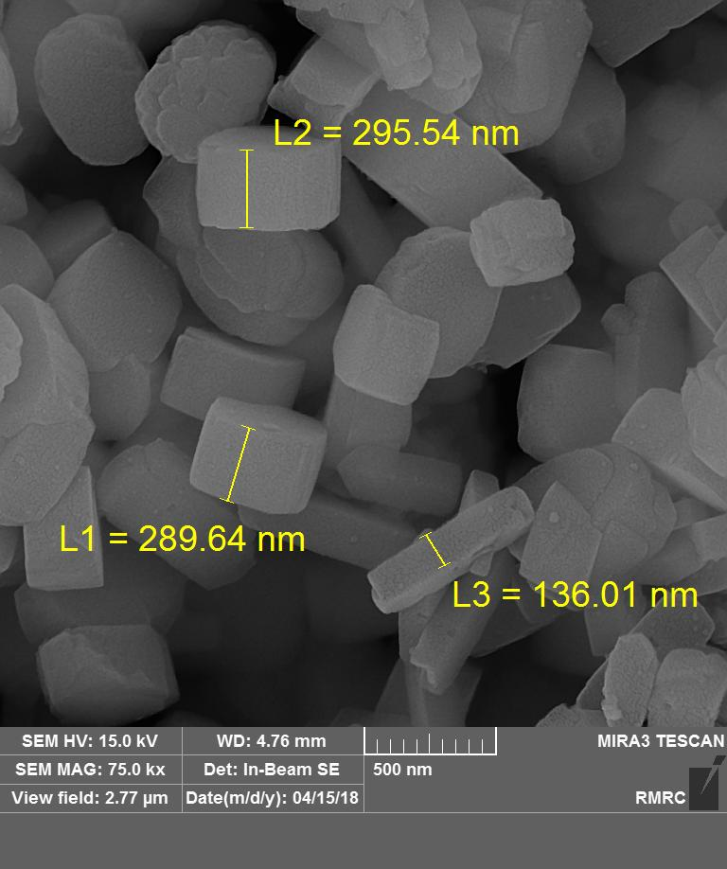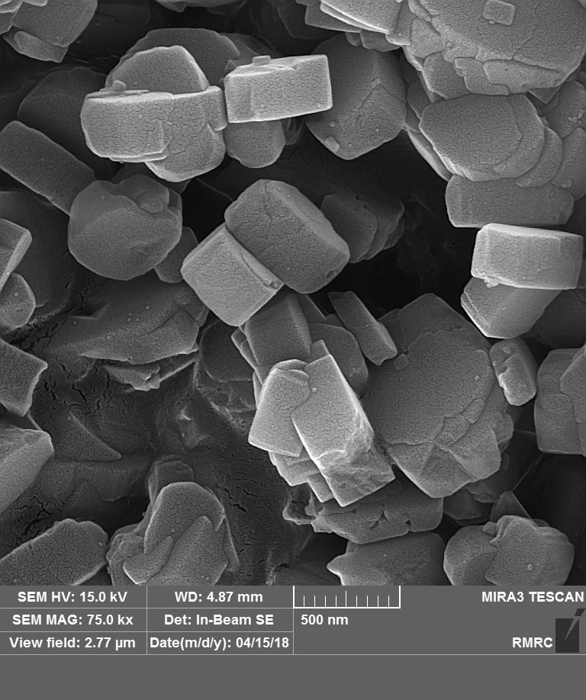
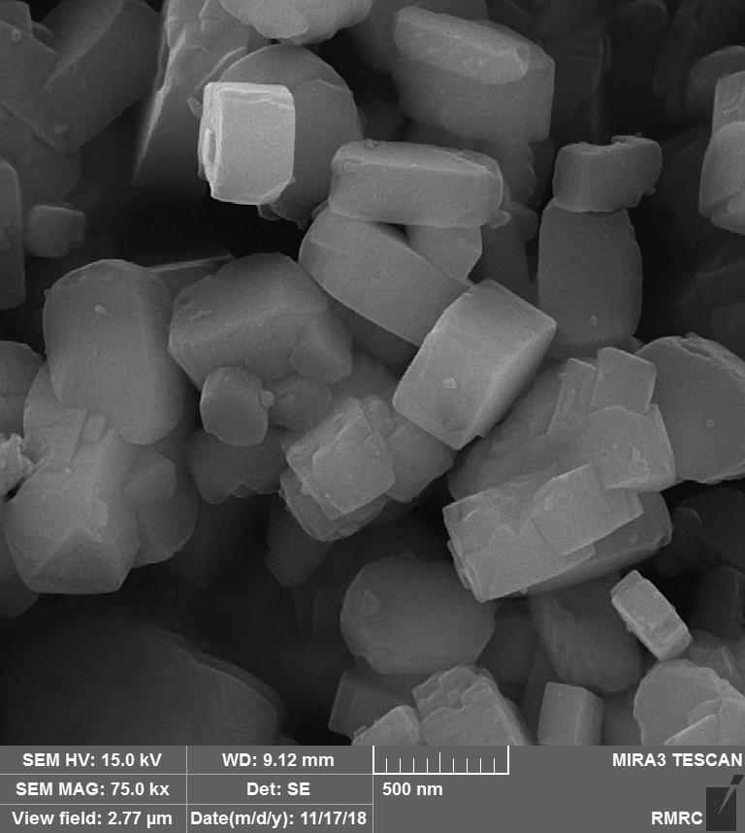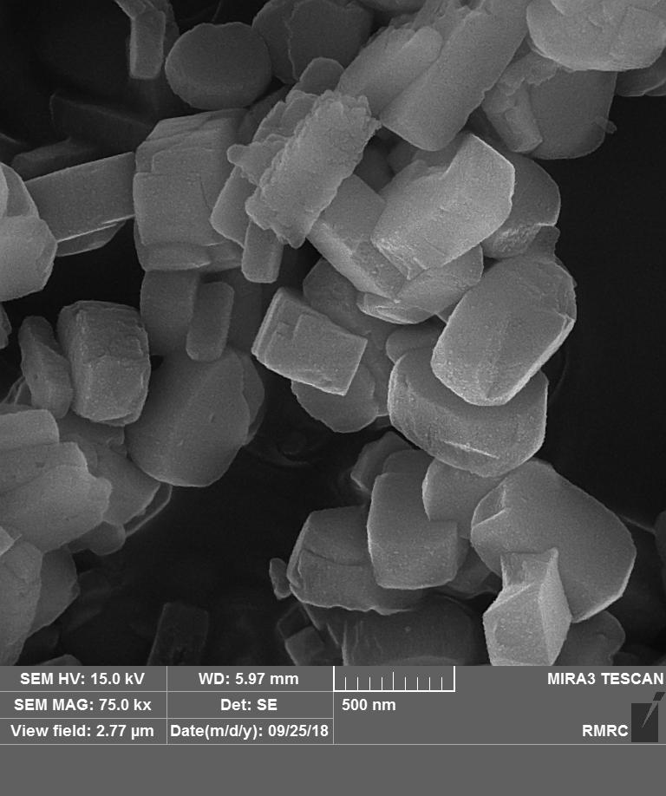
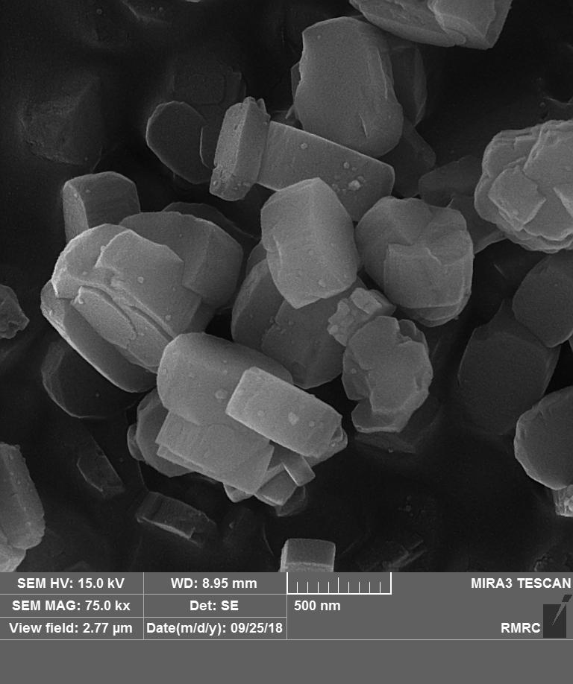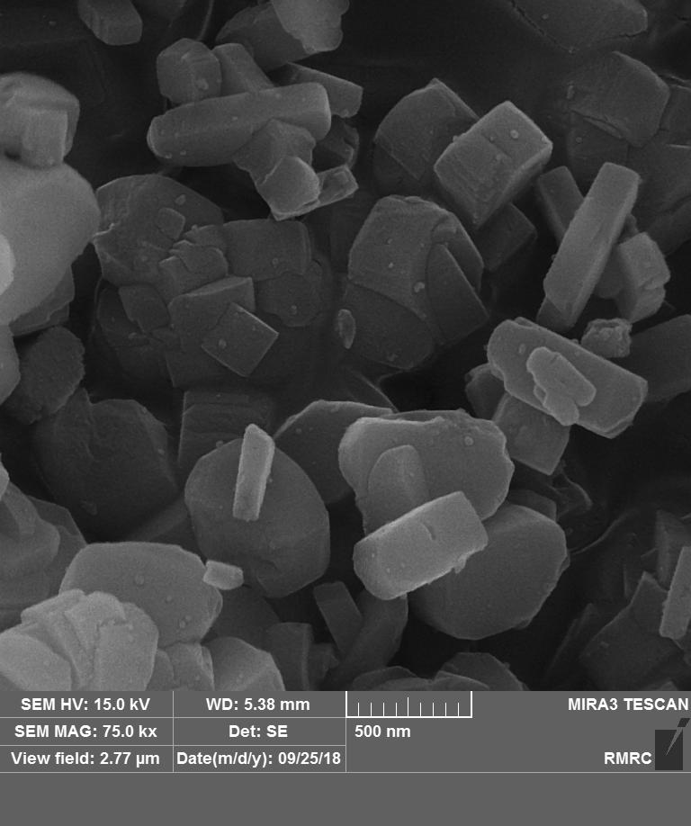
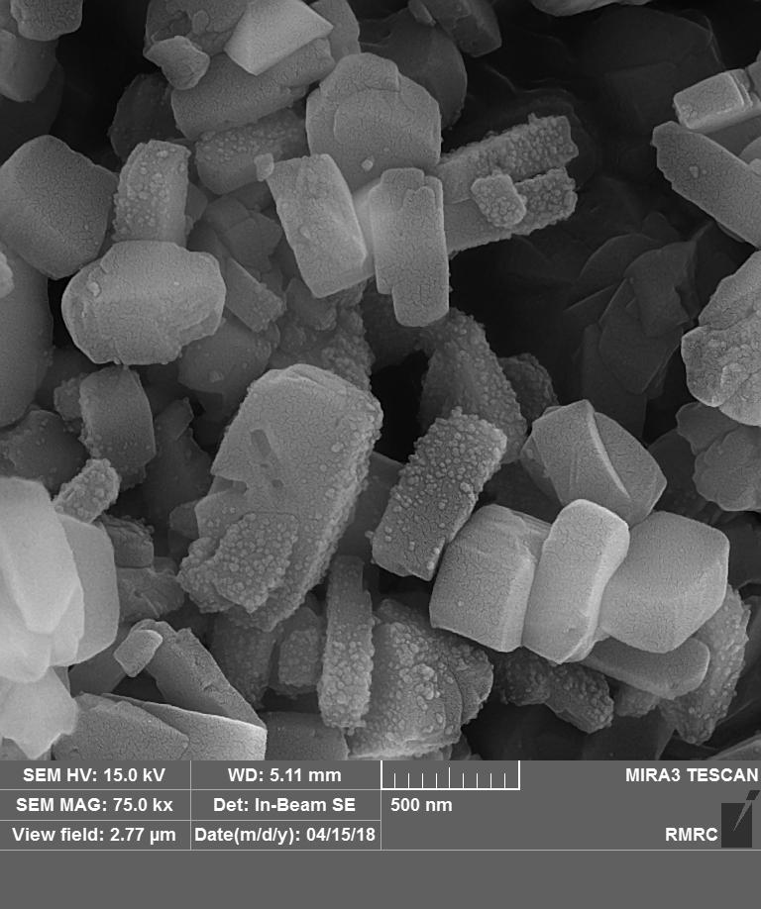
g

Fig 3. FE-SEM images of: (a) HZ5, (b) (5)Z/HZ5, (c) (8)Z/HZ5, (d) (10)Z/HZ5, (e) P(5)Z/HZ5, (f) P(8)Z/HZ5, (g) P(10)Z/HZ5.

g
f a
e a
a a
b a
c a
d a
*
Fig. 4. NH₃-TPD spectra of parent and modified HZSM-5 catalysts: (a) HZ5, (b) (5)Z/HZ5, (c) (8)Z/HZ5, (d) (10)Z/HZ5, (e) P(5)Z/HZ5, (f) P(8)Z/HZ5, (g) P(10)Z/HZ5.

1454
1545
d a
b a
e a
f a
g a
a a
c a
II
e a
f a
g
d a
c a
b a
a a
I
3728
3745
3610
Fig. 5. FT-IR spectra of OH groups (I) and pyridine adsorption (II) for: (a) HZ5, (b) (5)Z/HZ5, (c) (8)Z/HZ5, (d) (10)Z/HZ5, (e) P(5)Z/HZ5, (f) P(8)Z/HZ5, (g) P(10)Z/HZ5.
I
1023.7
1022.1
II
314.6
317.3
Fig. 6. XPS spectra of (I) ZnO/HZSM-5 and (II) Pt impregnated ZnO/HZSM-5 catalysts.

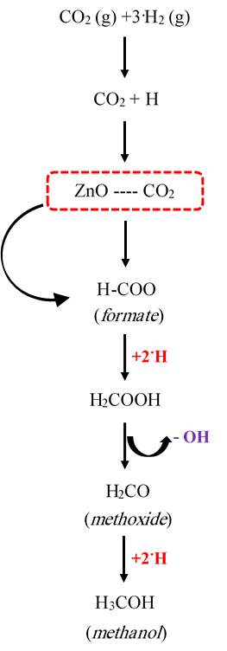
Fig. 7. Reaction network of CO₂ to methanol over ZnO catalysts [57]

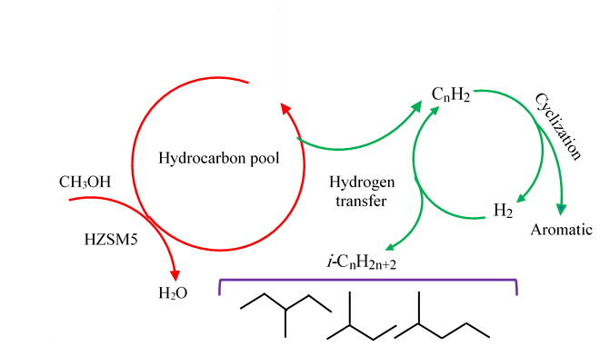
Fig. 8. Schematic of the hydrocarbon-pool mechanism for conversion of methanol to aromatics over HZSM-5 [58].

I
II
Fig. 9. CO₂ conversion (I) and selectivity to aromatics (II) over parent and modified catalysts.

