تنها دو رفرنس مربوط به سالهای 2018و2019 هستند، مابقی مراجع قبل از سال 2012 می باشد

Wellbore Optimum Stability of An Oil Well Drilled in a Highly Fractured Carbonate Reservoir based on Dipole Sonic Analysis
Ehsan Saadatzadeh*, Khalil Shahbazi, Reza Salehi
Petroleum University of Technology, Ahwaz, Iran
ehsansaadatzadeh@gmail.com
Abstract
Wellbore stability is dominated by in-situ stress and geomechanic parameters of formation rocks, so estimation of these parameters around the wellbore is so important. Studied well is a suitable candidate for investigation of wellbore stability, due to continuing directional drilling and planning for oriented perforation and hydraulic fracturing program from the wellbore and availability of dipole sonic, nuclear magnetic resonance (NMR), core and image log data to optimize and estimate wellbore stability conditions. In this study, the rock permeability is derived from dipole sonic analysis and for investigating certainty of model; these results are compared with NMR and special core analysis results. Then, based on these results pore pressure, in-situ stress, rock mechanical properties, stress and fracture distributions and anisotropy of formation are calculated and compared with Image log Results. Finally, from all of these data, the optimum mud weight to avoid wellbore failure can be estimated. As final results, the maximum horizontal stress direction is N33E that most of open fractures are in this direction. The minimum horizontal stress direction is in N57W, the safe and appropriate mud weight is in range between 6.5 to 7.5 ppg that it can be considered 7 ppg. This technique based on dipole sonic analysis that can be applied for investigation of wellbore stability in intervals with no core or image log analysis.
Keywords: Wellbore stability, in-situ stress, geomechanic, dipole sonic, fracture distributions, anisotropy, mud weight.

Nomenclature
UCS | Unconfined Compressive Strength | FZI | Flow Zone Indicator
STC | Slowness Time Coherency | DSI | Dipole Sonic Imager
SCAL | Special Core Analysis | NMR | Nuclear Magnetic Resonance
Shmax | Maximum Horizontal Shear Stress | Shmin | Minimum Horizontal Shear Stress
AZIM-FAST | Fast Azimuth of Shear Wave | DT | Wave Slowness (Sonic Log)
OBMI | Oil Based Mud Imager Log | UBI | Ultrasonic Borehole Imager Log
K_{st} | Stoneley Permeability | ppg | Pound per Gallons
N | North | E | East
RHOB | Density Log | IMF | Index Match Factor
K_{ist} | Permeability Index | T₀ | Tensile Stress

Introduction
More than 60% of the world's oil and 40% of the world's gas reserves are in carbonate reservoirs [11]. In these reservoirs, a combination of depositional fabrics, diagenetic alterations and fracturing controls the reservoir quality [2]. A natural fracture system in the rock can often be found near faults. Rock near faults can be broken into large or small pieces. If they are loose, they can fall into the wellbore and jam the string in the hole [17]. Accordingly, two kinds of wellbore instability problems are fractures and wellbore collapse [1]. On the other hand, wellbore fracture happens when mud weight is larger than fracture pressure so that wellbore in tension condition and wellbore collapse happens when mud weight in the wellbore does not support external pressure [23]. Detailed wellbore stability analysis needs a complete dataset including core and petrophysical data, which are not always available [10]. Unexpected or unknown behavior of rock is often the cause of drilling problems, resulting in an expensive loss of time, sometimes in a loss of part or even whole borehole [4, 6]. Rock formation remains stable and in equilibrium condition before drilling. After drilling, there is a disturbance and it changes the stability condition. Wellbore stability is dominated by in-situ stress system. When drilling a wellbore, the rock surrounding the wellbore must take the load that was previously taken by the removed rock. As a result, the in-situ stress changes in the borehole wall. This stress can lead to rock failure. This problem can be avoided by adjust the mud weight. So that stress concentration around the borehole wall can be managed to minimize borehole failure [23]. The unconfined compressive strength (UCS) of sedimentary rocks is key parameter needed to address a range of geomechanical problems ranging from limiting wellbore instabilities during drilling [15], to assessing sanding potential [18] and quantitatively constraining stress magnitudes using observations of wellbore failure [24]. Borehole stability is a continuing problem which results in substantial yearly expenditures by the petroleum industry [4, 7]. Wellbore stability predictive models may also be used to design appropriate completions for inflow problems where hole collapse and associated sand production, or even the complete loss of the well, may be concerned [14]. Recognizing of stress direction is very important in exploration and production of the oil and it is effective on wellbore stability, flow unit patterns, fluid flow in fractured reservoirs, cap rock failure and fault reactivation [21]. Natural fractures that are parallel to the Maximum Horizontal Stress (Shmax) - (or oblique to that) are capable to tensile or shear deformation and mostly observed that these types of fractures are more permeable (open fractures) [20].
Most of the oil producing horizons of Iran is related to the Oligocene–Miocene Asmari Formation [19]. Due to lack of necessary data, the role of geomechanic parameters is still unknown in most of the Iranian reservoirs [10]. For current study, an exceptionally comprehensive dataset (Cores, Image log, Dipole Sonic log and Conventional Logs) in an oil well enabled us to characterize various geomechanic parameters, petrophysical aspects of rock mechanic parameters, delineate their effect on reservoir anisotropy and investigate mud weight window as an important factor in wellbore stability in the Asmari formation of an supergiant highly fractured oilfield of southwestern Iran. The studied well location in this reservoir is represented in figure 1.
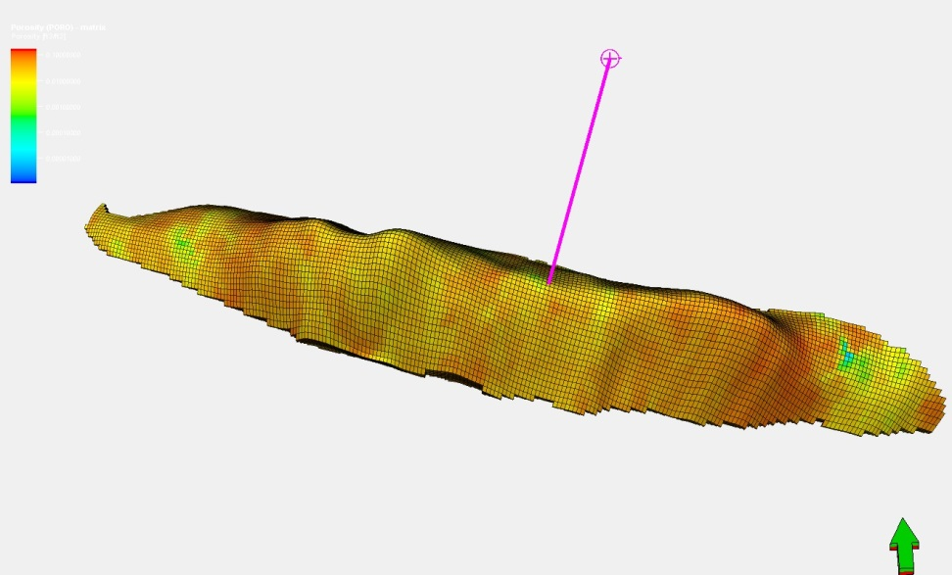
Figure 1: Well Location in Reservoir

Materials and Methods
In this study, as first step, the rock permeability is derived from dipole sonic analysis by slowness-time coherency (STC) technique and flow zone indicator (FZI) model, and for investigating certainty of model, these results are compared with nuclear magnetic resonance (NMR) and special core analysis (SCAL) permeability results. Then, based on these results, pore pressure, in-situ stress, rock mechanical properties, stress and fracture distributions and anisotropy of formation are calculated. Afterwards, the anisotropy, stress and fracture distributions are compared with Image log results. Finally, from all of these data, the optimum mud weight to avoid wellbore failure can be estimated. By generating mud safe window, problems during drilling related to wellbore instability can be avoided. The schematic of overall work is represented in figure 2.

Figure 2: Schematic of Overall Work of Study

Dipole Sonic Imager Tool
Dipole Sonic Imager Log (DSI) is a modern sonic log that makes compressional, shear and stoneley waves to recognize petrophysical and geomechanical properties of the rocks. The schematic and specification of this tool is presented in figure 3.
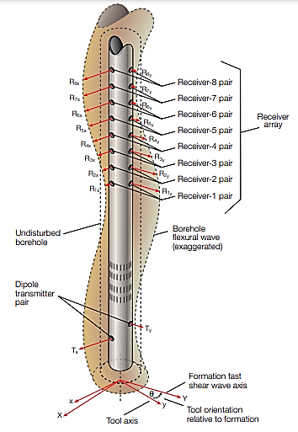
Figure 3: Schematic and Specification of DSI Tool
Permeability Derivation from Dipole Sonic Log
Considering the clearness of the distance between the receivers of DSI tool, by calculating the linear slope obtained from the connection of similar components in different receivers, the velocity of that component is calculated. The higher the slope of this line, the higher the velocity of the sonic wave and the lower its slowness. Therefore, naturally, compressional wave (P-Wave) slowness will be less than shear wave (S-Wave) and shear wave slowness will be less than stoneley wave. By using the mathematical technique of similarity analysis (Semblance), all waveforms received in different receivers, using a moving time window, are scanned until similar arrival times based on the degree of coherence, are separated and all types of sonic waves (P, S and Stoneley) are distinguished from each other in the monopole mode. Slowness Time Coherency (STC) is obtained from plotting the slownesses calculated from the similarity analysis in terms of arrival time. By connecting the STC of different depths to each other, it is possible to derive the attenuation of different components of the sonic wave. Stoneley waves in low frequencies are propagated inside the wellbore like a tube wave. When the Stoneley wave passes through the permeable portion or fracture, some of the energy of the wave is reduced, which results in wave attenuation and an increase in its slowness value. Fractures and permeable areas have different effects on the Stoneley wave. It should be noted that the parameter measured with the Stoneley wave indicates the ability of the fluid to move inside the formation (Stoneley Permeability). Among the factors affecting the slowing down of the Stoneley wave propagated inside the formation, we can mention the lithology, the effect of the mudcake in front of the permeable zone, and the properties of the fluid inside the formation. In FZI model by using relations 1 to 5, it is possible to estimate the permeability from Stoneley waves:
${Dt}_{st Calc}=\sqrt{{{Dt}_{f}}^{2}+\left(\frac{ρ_{f} ☓{{Dt}_{sh}}^{2} }{Rhob}\right)}$ (Equation 1)
$K_{ist}=\frac{{Dt}_{st DSI}}{{Dt}_{st Calc}}$ (Equation 2)
$IMF= \sum{\left({IMF}_{i}×V_{i}\right)}$ (Equation 3)
$FZI=IMF ×\left(K_{ist}-1\right)$ (Equation 4)
$K_{st}=1014× {FZI}^{2}×\left[\frac{∅_{e}^{3}}{{\left(1-∅_{e}\right)}^{2}}\right]$ (Equation 5)
Where ${Dt}_{st Calc}$, ${Dt}_{f}$, ${Dt}_{sh}$, ${Dt}_{st DSI}$,$ρ_{f}$, $Rhob$,$K_{ist}$ , $IMF$,$V_{}$, i, $FZI$, $∅_{e}$ and $K_{st}$ are stoneley slowness, mud filtrate slowness, shear slowness, DSI stoneley slowness, mud filtrate density, bulk density, permeability index, index match factor, mineral volume, mineral, flow zone indicator, effective porosity and stoneley permeability, respectively [16].
Geomechanical Parameters Estimation
The compressional slowness (DTC) and shear slowness (DTSh) obtained from the DSI were used in combination with the bulk-density to compute the dynamic elastic moduli. The following dynamic elastic moduli can be computed using the DSI, formation density data [18]:
${Dynamic Shear Modulus= G}_{Dyn}=(92903.04)\frac{RHOB}{{{Dt}_{sh}}^{2}}$ (Equation 6)
${Dynamic Bulk Modulus=K}_{Dyn}=\left(92903.04\right)RHOB\frac{1}{{{Dt}_{c}}^{2}}-\frac{4}{3}{ G}_{Dyn}$ (Equation 7)
${Dynamic Young's Modulus= E}_{Dyn}=2{ G}_{Dyn}(1+ν)$ (Equation 8)
${Dynamic Poisson's Ratio= ν}_{Dyn}=\frac{0.5{{({Dt}_{sh}}/{{Dt}_{c})}}^{2}-1}{{({{Dt}_{sh}}/{{Dt}_{c}})}^{2}-1}$ (Equation 9)
${Static Young's Modulus= E}_{sta}=(-2.21∅_{e}+0.963)E_{Dyn}$ (Equation 10)
The static Young’s modulus was used to get the static Unconfined Compressive Strength (UCS) profiles. For all the formations, the following correlation has been used [23]:
$UCS=\left(4.1E_{sta}+3\right)145 (psi)$ (Equation 11)
The tensile strength is obtained from the UCS by dividing it by a certain number. Generally, this number varies between one-tenth and one-twelfth of the UCS. For the Asmari formation in this study, it was taken as one-tenth of the UCS computed by the Young’s modulus correlation [23].
$T_{0}=\frac{\left(UCS\right)}{10}$ (Equation 12)
Anisotropy Investigation
In deviatoric stresses condition, fractures that are parallel to SHmax remain open and fractures perpendicular to SHmax will be closed. In this medium fast shear wave moves to open fractures direction (SHmax direction) and slow shear wave moves to closed fractures direction (SHmax direction) [8]. Fast shear wave direction can be determined as AZIM-FAST curve that shows higher compaction direction in rock (Figure 4). This curve shows the direction in which the rock is denser, and in this way, the direction of the maximum horizontal stress (SHmax) can be determined at all depths. Since the Breakouts in the shear waves are in direction of minimum horizontal stress (Shmin), as the anisotropy direction of achieved raw data is not parallel with formation anisotropy direction, axis of the tools can be paralleled with the formation anisotropy direction [8]. By calculating the anisotropy, two curves showing the minimum and maximum energy (MIN and MAX- ENERGY) are finally obtained. In the isotropic depth interval, the values ​​of energy anisotropy are zero, and in the anisotropic depth interval, the reading value depends on the intensity of anisotropy. Also, anisotropy is compared with oil based mud-ultrasonic borehole Imager log (OBMI-UBI) anisotropy to check certainty of model.
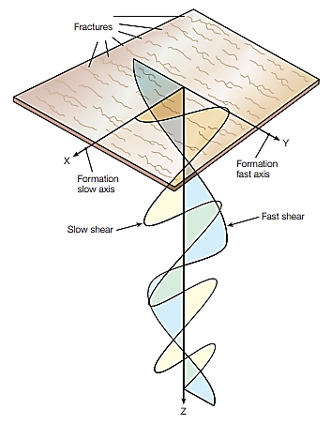
Figure 4: Shear Waves Splitting in Pressence of Fractures
Wellbore Stability Calculations
To analyze the stability of the wellbore, the mechanical properties of the rock and the rock stresses must be estimated. Various parameters affect wellbore stability, the most important controllable parameter is the weight of drilling mud. After determining the mechanical properties of the rock, pore pressure and rock stresses in the area near wellbore, the suitable window for drilling fluid weight is determined.

Results and Discussion
By applying STC analysis, the compressional, shear and stoneley waves are derived from dipole sonic log (figure 5). The results of stoneley permeability by FZI model and its comparison with core permeability through SCAL are represented in figure 6.
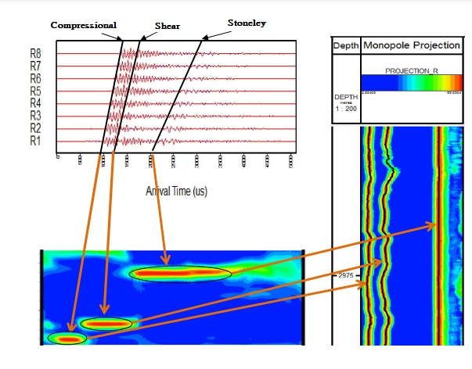
Figure 5: STC Analysis Results for Compressional, Shear and Stoneley Waves Derivation
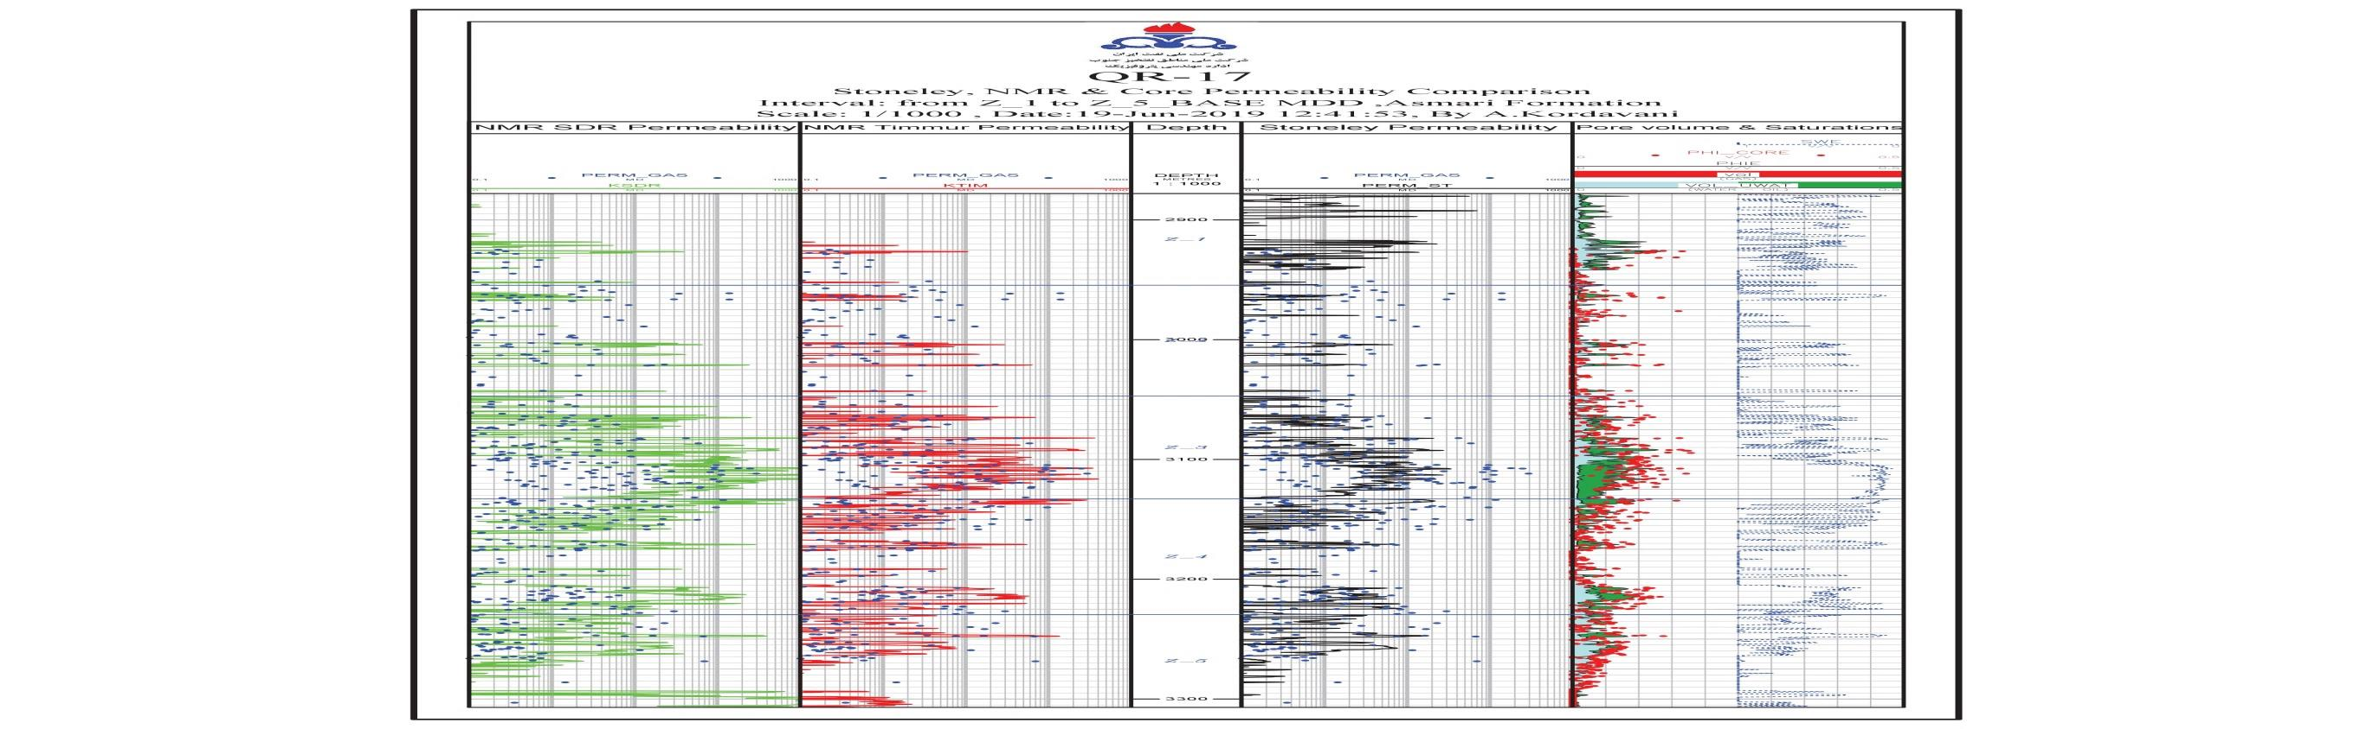
Figure 6: Stoneley Permeability from FZI Model and Its Comparison with SCAL
Comparison of calculated permeability results with NMR log permeability through two models (Timmur-Coats and SDR) are represented in figure 7 and summarized in table 1. According to good match of sonic results with SCAL and NMR, certainty of model is confirmed and it can be applied for geomechanical study.
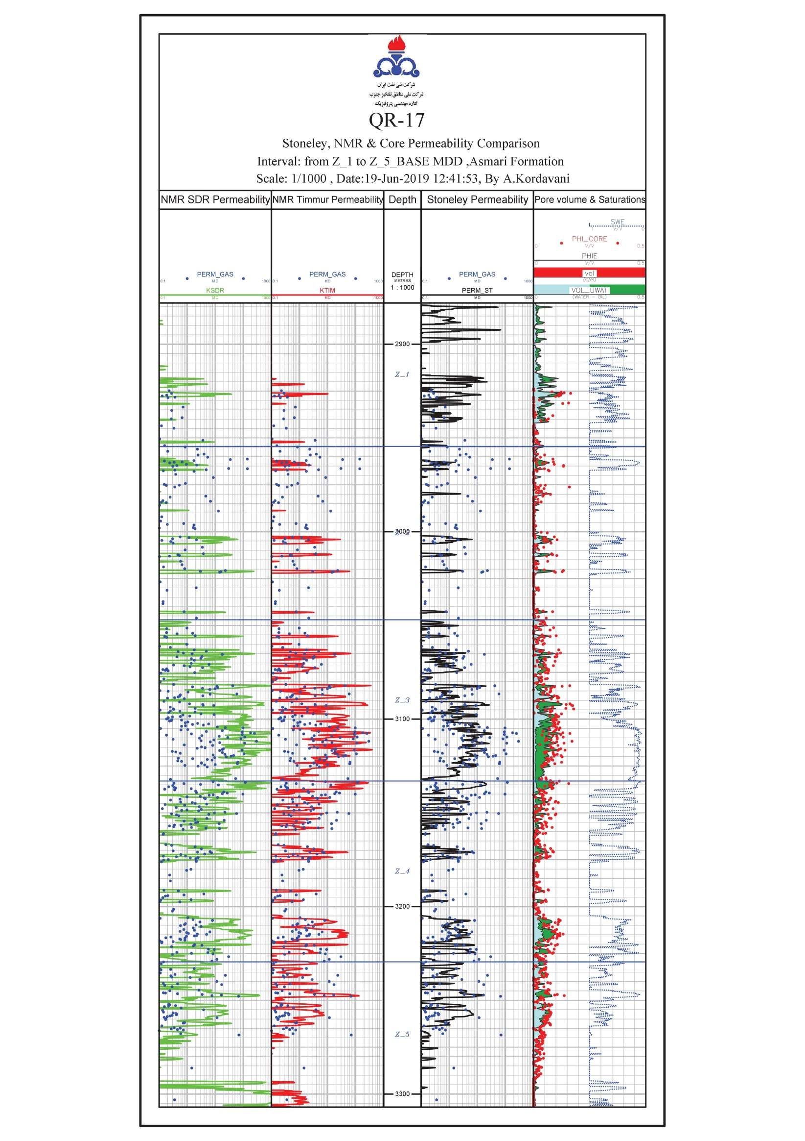
Figure 7: Comparison of Stoneley Permeability with SCAL and NMR Results

Table 1: Summary of Permeability Results
Layer | Interval (Meter) | SCAL Perm (mD) | SDR Perm (mD) | Timmur-Coats Perm (mD) | Stoneley Perm (mD)
Zone 1 | 2875-2950 | 1.559 | 1.81 | 1.82 | 1.71
Zone 2 | 2950-3045 | 0.472 | 0.25 | 0.26 | 0.16
Zone 3 | 3045-3125 | 2. 930 | 2.98 | 3.13 | 3.30
Zone 4 | 3125-3230 | 1. 391 | 1.15 | 1. 11 | 1.29
Zone 5 | 3230-3305 | 0.753 | 0.81 | 0.83 | 0.88

Geomechanical moduli of formation rock are estimated from the sonic wave and their changes in whole depth interval of the wellbore are represented in figure 8.
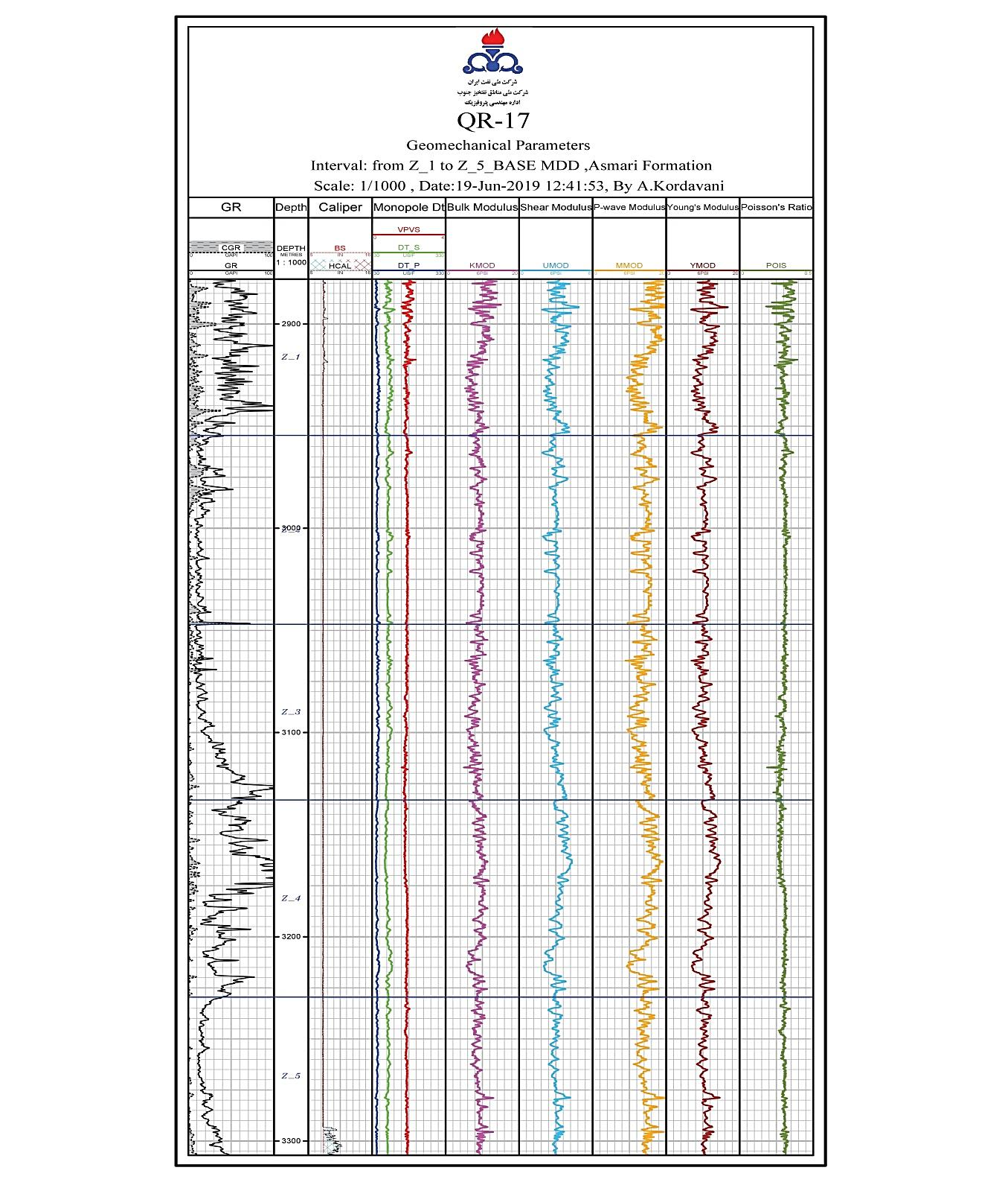
Figure 8: Geomechanical Moduli for Whole Interval
Unconfined Compressive Strength (UCS) profile versus static Young's modulus that indicates the effective porosity changes in carbonate formation in well interval is represented in figure 9.
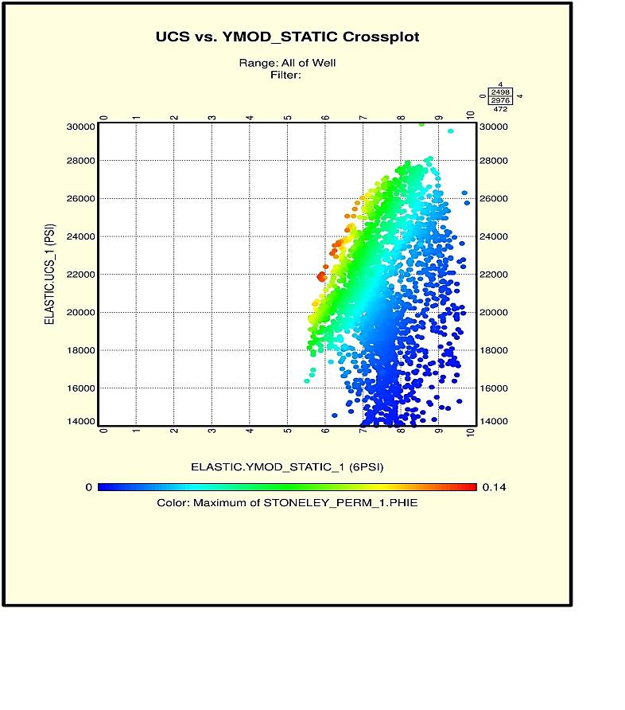
Figure 9: UCS vs. Static Young's Modulus (Changing Color is Effective Porosity)
Polygon of calculated stresses are represented in figure 10 that indicates stress trend in wellbore.
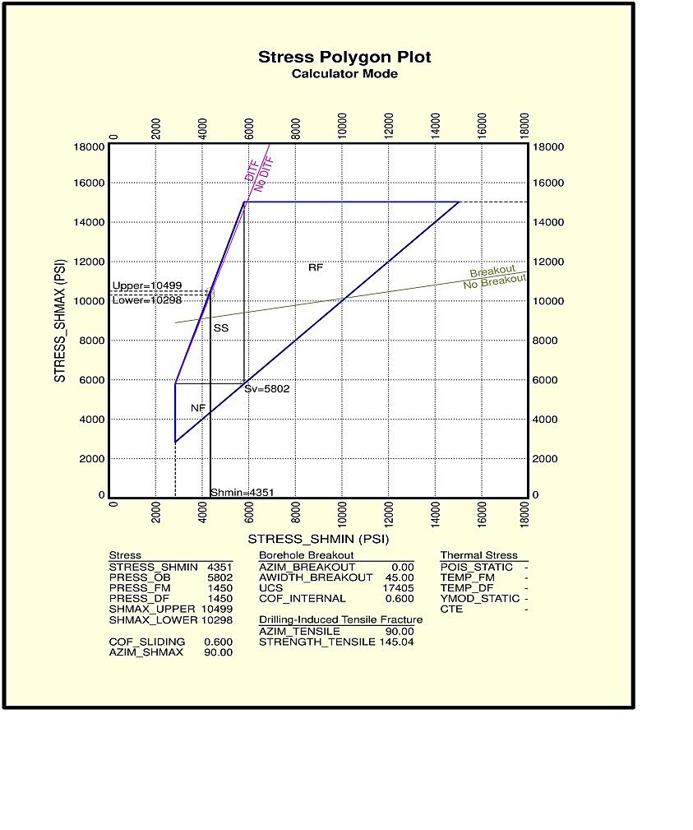
Figure 10: Stress Trend in Depth Interval
Anisotropy results rising from DSI and their comparison with OBMI-UBI results are presented in figure 11. According to this figure, the difference between Min and MAX-ENERGY is the anisotropy intervals that are matched with image log. Also AZIM-FAST shows the direction of maximum horizontal stress (SHmax) and breakouts represent the minimum horizontal stress (SHmin) direction.
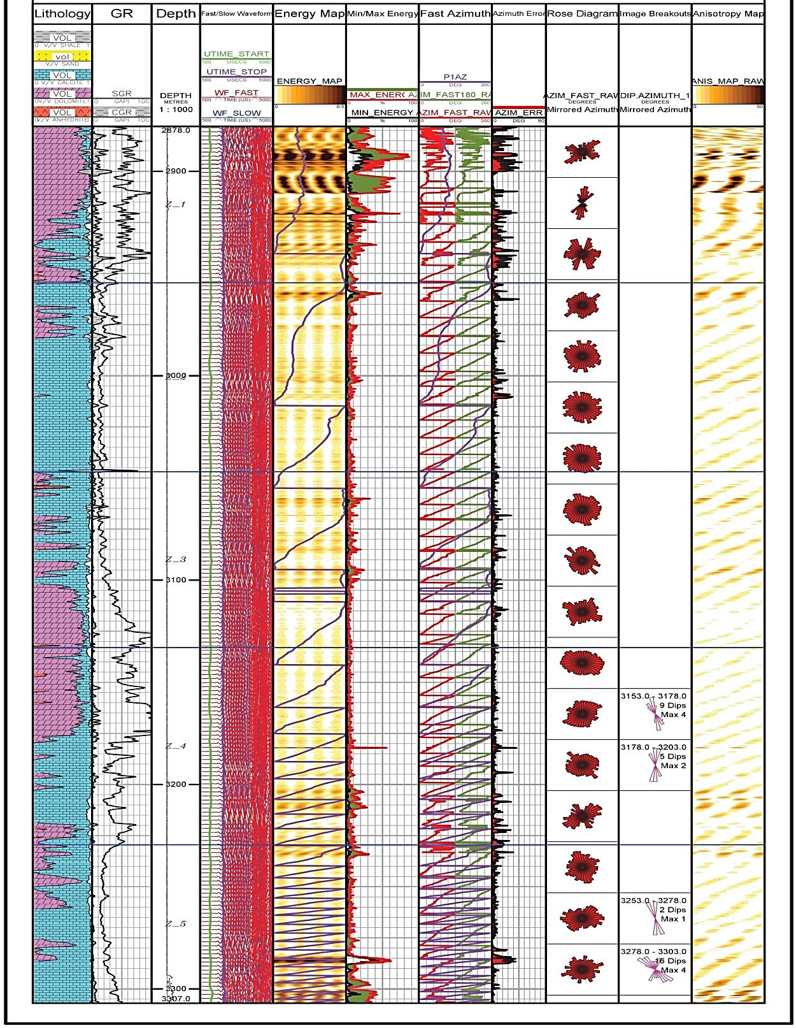
Figure 11: Anisotropy Results (DSI and UBI Comparison)
Then wellbore walkout plot by applying dip and azimuth of bedding and fractures is prepared (figure 12) and based on this plot, wellbore stress is plotted according to maximum and minimum horizontal stresses (figure 13) to distinguish the tensile failures and breakout failures of overall depth interval. Also the rose diagram of bedding and fractures that represents maximum horizontal stress direction is plotted in figure 14.
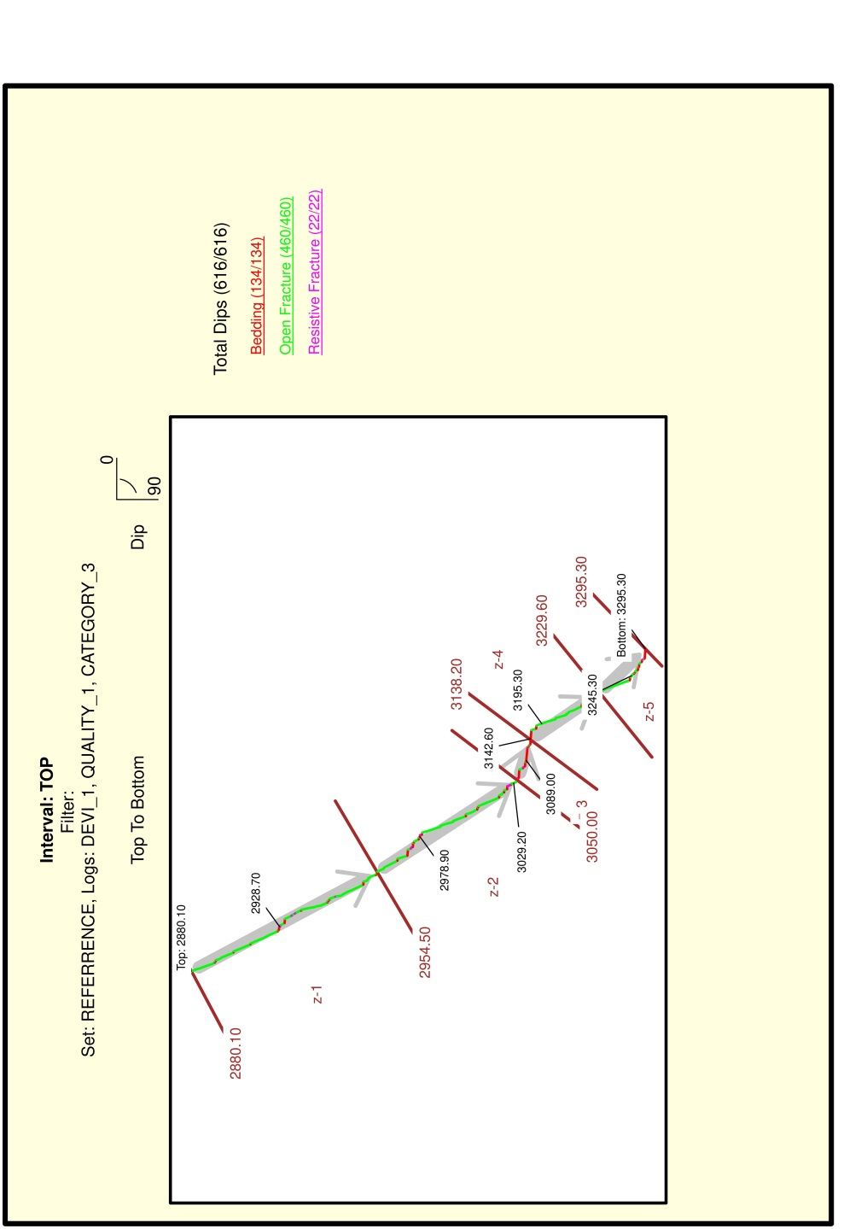Figure 12: Wellbore Walkout Plot based on Bedding and Fractures Dip and Azimuth
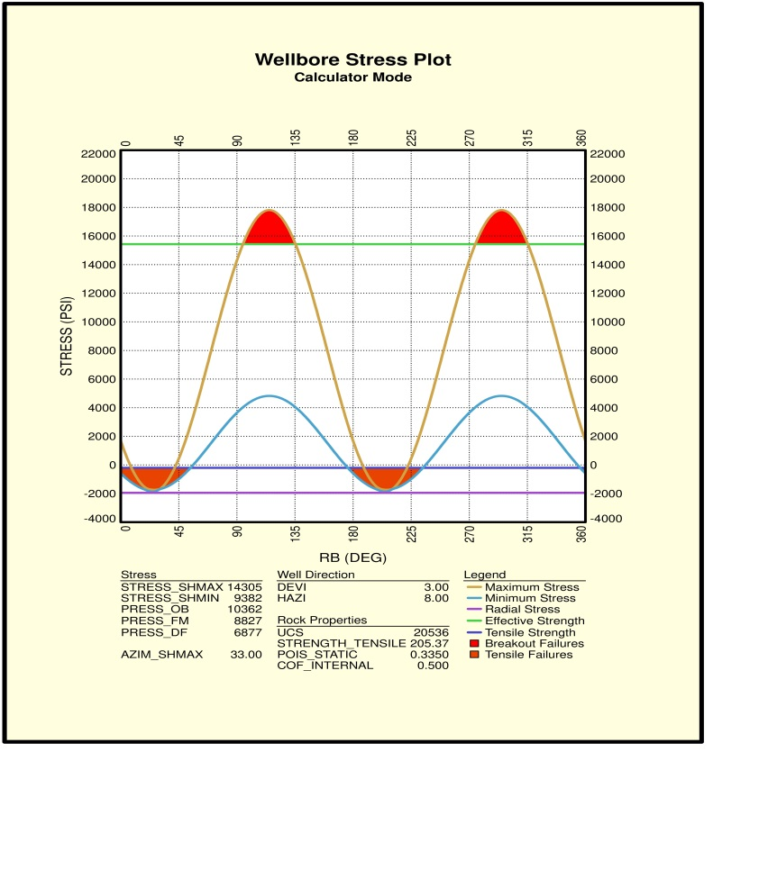
Figure 13: Wellbore Stresses in Overall Interval
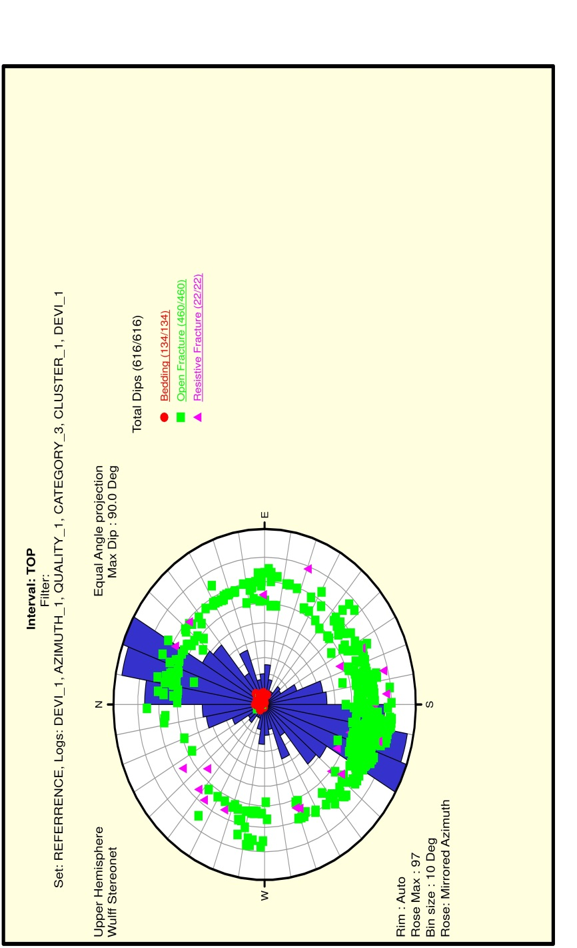Figure 14: Rose Diagram of SHmax based on Bedding and Fractures Distributions

Stereonet plot of wellbore stability based on rock strength is presented in figure 15. Also stereonet plot of wellbore stability based on mud weight is presented in figure 16. In these figures the direction of SHmax is shown. SHmax direction is calculated as N33E.
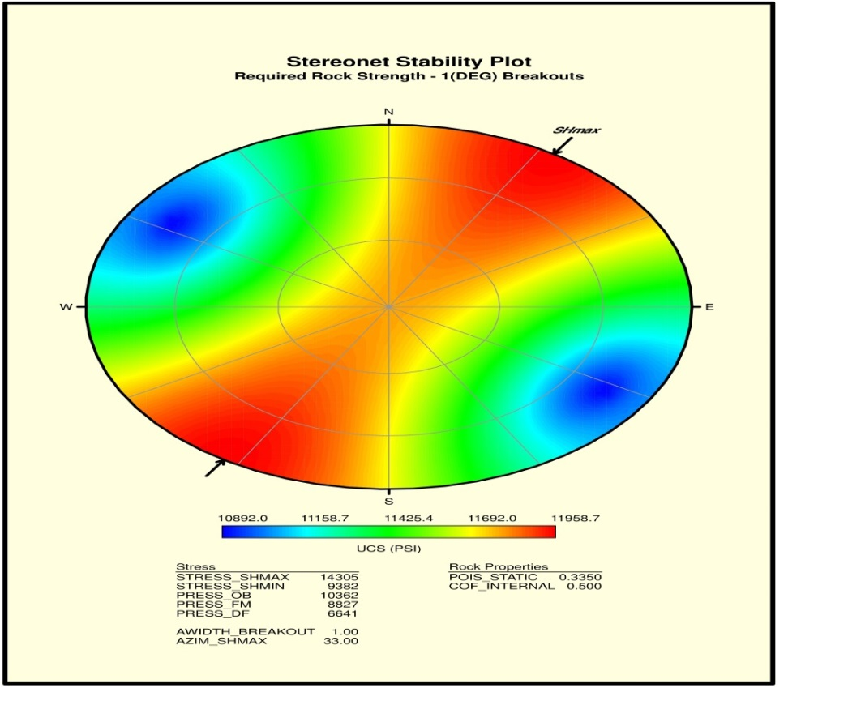
Figure 15: Stereonet of Wellbore Stability Based on Rock Strength
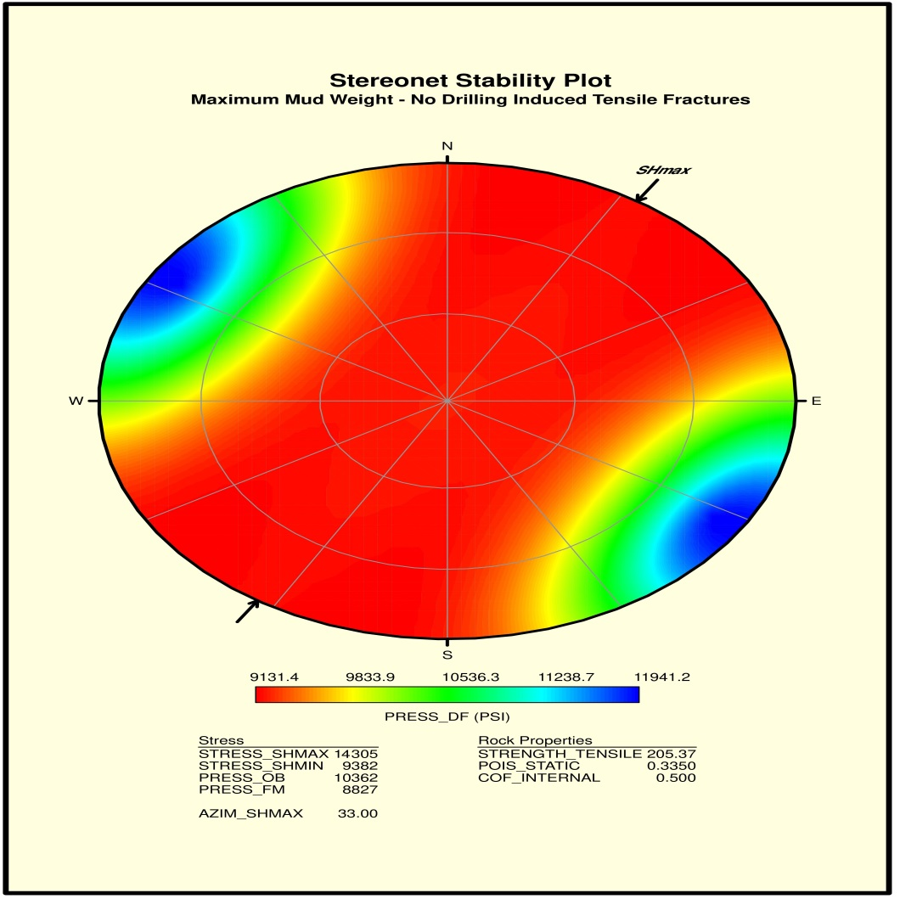
Figure 16: Stereonet of Wellbore Stability Based on Mud Weight
The calculated pressures based on geomechanical parameters of rock and drilling fluid transforms to equivalent mud weight. The appropriate mud weight range for safe drilling is presented as mud weight window in figure 17. In this figure, safe drilling is considered between fluid kick and formation breakout by mud and based on this graph, the safe mud weight is between 6.5 to 7.5 ppg.

Conclusions
Based on results, geomechanical moduli of rock does not change significantly from top to bottom of depth interval of formation and it may be considered constant. The maximum amount of anisotropy is on upper and middle part of layer 1 and in middle and lower part of layer 5. The maximum horizontal stress direction is N33E that most of open fractures are in this direction. The minimum horizontal stress direction is in N57W. According to steronet of stability plots, the maximum rock stresses are in SHmax directions and maximum mud weight spends in this direction to control and stable maximum stress. Directional drilling and oriented perforations should be normal to N33E to cut maximum open fractures. Hydraulic fracturing process should be in direction of N57W to spend minimum energy for producing optimized and deepest fracture. For continuing directional drilling in wellbore with minimum sand production, the safe and appropriate mud weight is in range between 6.5 to 7.5 ppg that it can be considered 7 ppg for average. In overall interval, with this mud weight and drilling in normal direction to N33E, problems during drilling related to wellbore instability can be avoided. As final conclusion, it can be said that DSI permeability and anisotropy results have a good match with NMR/SCAL permeability and OBMI-UBI anisotropy results. So this technique can be applied in the wellbores with no core or NMR or Image log analysis.

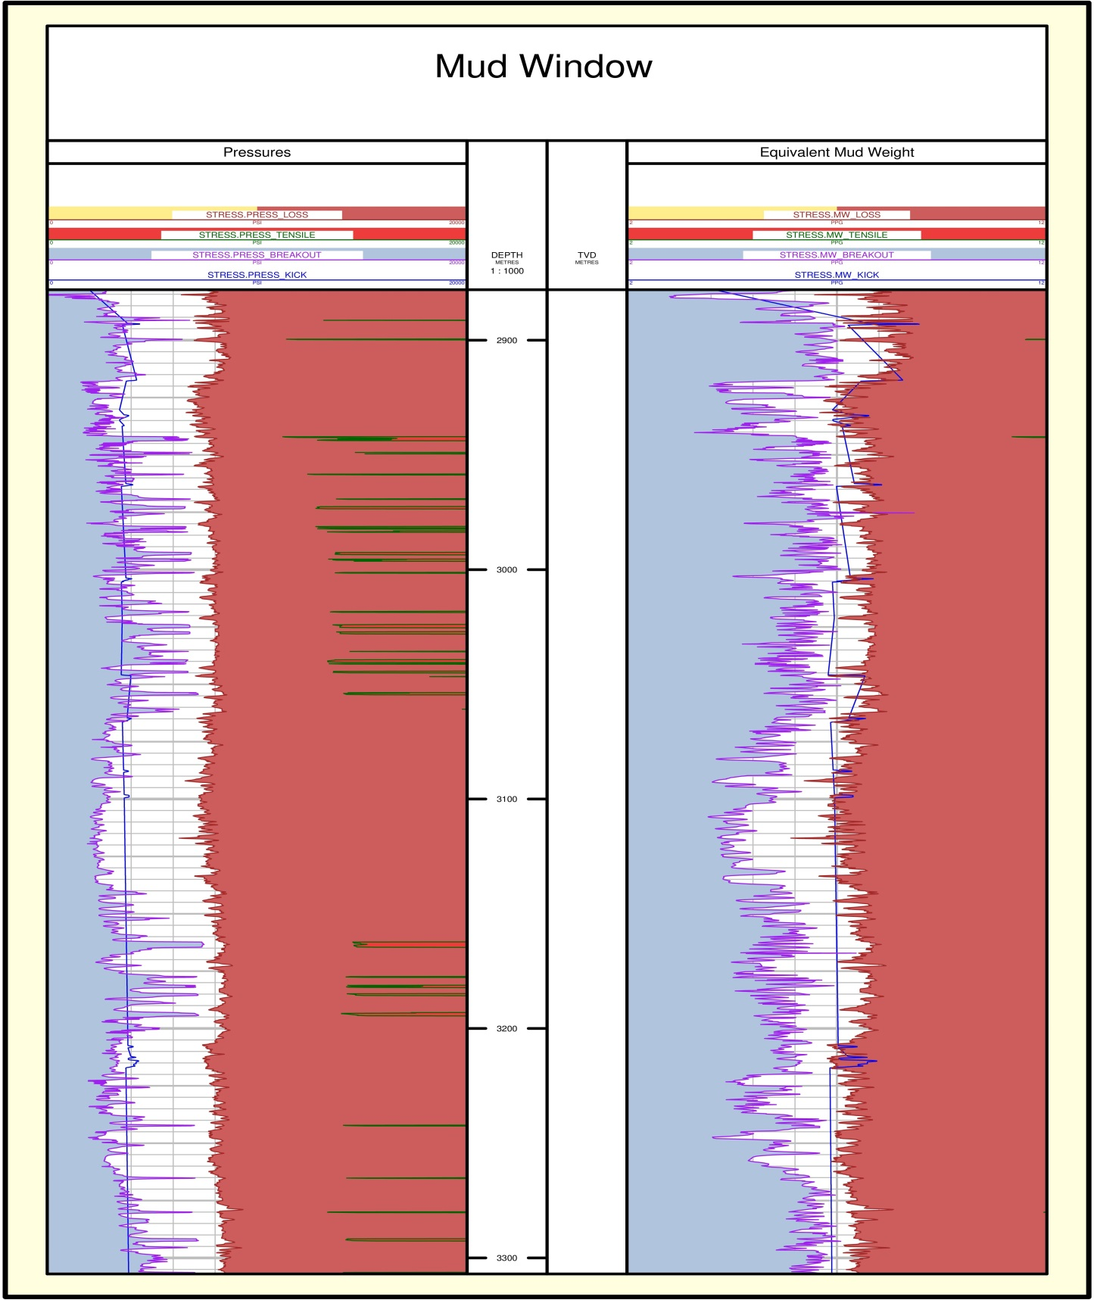Figure 17: Appropriate Mud Window for Safe Drilling
References
- Aadnoy, B. S. & Hansen, A. K. (2005) Bounds on In-situ Stress Magnitudes Improve Wellbore Stability Analyses. Journal of Petroleum Science and Engineering, pp. 115 - 120.
- Ahr, W.M. (2008) Geology of Carbonate Reservoirs. John Wiley and Sons.
- Alford RM. (1986) Shear Data in the Presence of Azimuthal Anisotropy Dilley, Texas, 56th SEG Annual International Meeting, Houston, 476-479.
- Awal, M.R., Khan, M.S., Mohiuddin, M.A., Abdulraheem, A., Azeemuddin, M. (2001) A New Approach to Borehole Trajectory Optimization for Increased Hole Stability, paper SPE 68092 presented at the 2001 SPE Middle East Oil Show, 17-20 March, Bahrain.
- Biot, M.A., (1956) Theory of propagation of elastic waves in a fluid-saturated porous solid, I. Low-Frequency Range. J. Acoust. Soc. Am. 28, 168–178.
- Bradley, W. (1978) Bore Hole Failure Near Salt Domes, paper SPE 7503 presented at the 53th Annual Fall Technical conference and Exibition of the SPE of AIME, 1-3 October, Houston, Texas.
- Bradley, W. (1978) Bore Hole Failure Near Salt Domes, paper SPE 7503 presented at the 53th Annual Fall Technical conference and Exibition of the SPE of AIME, 1-3 October, Houston, Texas.
- Brie, A., Endo, T., Hoyle, D., Codazzi, D., Esmersoy, C., Hsu, K., Denoo, S., Mueller, M.C., Plona, T., Shenoy, R., Sinha, B. (1998) New Directions in Sonic Logging. Oilfield Review: 4, 40–55.
- Coates, R., Kane, M., Chang, C., Esmersoy, C., Fukuhara, M., and Yamamoto, H. (2000) Single-well sonic imaging: High-definition reservoir cross-sections from horizontal wells: SPE 65457.
- Ezzati. M, et al. (2018) Characterization of micro-fractures in carbonate Sarvak reservoir, using petrophysical and geological data, SW Iran, Journal of Petroleum Science and Engineering, 170, 675-695.
- Lee, H., Lee, S.G., Doyle, P.S. (2015) Photo patterned oil-reservoir micromodels with tailored wetting properties. Lab a Chip 15 (14), 3047–3055.
- Khoshbakht, F., Azizzadeh, M., Memarian, H., Nourozi, G. H., Moallemi, S. A. (2012) Comparison of electrical image log with core in a fractured carbonate reservoir. Journal of Petroleum Science and Engineering: 86–87, 289– 296.
- McLean, M.R. Addis, M.A. (1990) Wellbore Stability Analysis: A Review of Current Methods of Analysis and Their Field Application, paper IADC/SPE 19941 presented at the 1990 IADC/SPE Drilling Conference, 27 February - 2 March, Houston, Texas.
- McLellan, P.J., Wang, Y. (1994b ) Predicting the Effects of Pore Pressure Penetration on the Extent of Wellbore Instability: Application of a Versatile Poro-Elastoplastic Model, paper SPE/ISRM 28053 prepared for presentation at the 1994 Eurock SPE/ISRM Rock Mechanics in Petroleum Engineering, Delft, The Netherlands, 29- 31 August 1994.
- Moos, D., Peska, P., Finkbeiner, T., Zoback, M.D. (2003) Comprehensive wellbore stability analysis utilizing quantitative risk assessment. J. Pet. Sci. Eng. 38, 97–110.
- Morris, R.L., Grine, D.R., and Arkfeld, T.E. (1964) Using compressional and shear wave acoustic amplitudes for the location of fractures: Journal of Petroleum Technology, 623-632.
- Nguyen, V., Abousleiman, Y., Hoang, S. (2007) Analyses of Wellbore Instability in Drilling Through Chemically Active Fractured Rock Formations: Nahr Umr Shale, paper SPE 105383 presented at the 15th SPE Middle East Oil & Gas Show and Conference, 11-14 March, Bahrain International Exhibition Centre, Kingdom of Bahrein.
- Santarelli, F.J., Detienne, J.L., Zundel, J.P (1989) Determination of the mechanical properties of deep reservoir sandstones to assess the likelihood of sand production. In: Maury, V., Fourmaintraux, D. (Eds.), Rock at Great Depth. A.A.Balkema, Brookfield, VT, pp. 779–787.
- Schlumberger (1997) DSI Dipole Shear Sonic Imager: Corporate brochure SMP-9200, 36 pages.
- Serra, O. (1989) Formation Micro Scanner Image Interpretation, Schlumberger Education Services.
- Sibson, R. H. (1996) Structural permeability of fluid driven fault-fracture meshes. Journal of Structural Geology: 18, 1031–1042.
- Simangunsong, R.A., Villatoro, J.J., Davis, A.K. (2006) Wellbore Stability Assessment for Highly Inclined Wells Using Limited Rock-Mechanics Data, paper SPE 99644 presented at the 2006 SPE Annual Technical Conference and Exhibition, 24-27 September, San Antonio, Texas, U.S.A.
- Tranggono. H. (2019) Wellbore Collapse Failure Criteria and Drilling Optimization, Master Thesis, FACULTY OF SCIENCE AND TECHNOLOGY, University of Stavenger.
- Zoback, M.D., Barton, C.A., Brudy, M., Castillo, D.A., Finkbeiner, T., Grollimund, B.R., Moos, D.B., Peska, P., Ward, C.D., Wiprut, D.J. (2003) Determination of stress orientation and magnitude in deep wells. Int. J. Rock Mech. Min. Sci. 40, 1049–1076.

